Greacen Associates, LLC

North Dakota Supreme Court

Family Mediation Pilot Project

Evaluation

Second Interim Report

November 10, 2010

Executive Summary

During its initial two years, the Family Law Mediation Pilot Project has been successful in meeting its objectives.

- The project has been implemented successfully from an administrative standpoint, with the establishment of procedures, the selection and training of mediators, the augmentation of the UCIS system to support automated data gathering, the modification of the new Odyssey case management system to support the project, the gathering of survey and other data for the project, and the preparation and adoption of ethical guidelines and a process for enforcement of those guidelines.

- The project has expanded successfully beyond the initial two pilot districts to three additional districts. The project administrator has recruited, selected, and trained additional mediators for the new districts and informed judges and court staff of the project’s procedures. The Supreme Court has decided to make the project statewide, requiring additional recruitment, selection and training of mediators and training for judges and court staff.

- All participants praise the performance of the project administrator.

- The project has assigned mediators and issued mediation orders in 311 cases. Two hundred and twenty-two of those cases were completed by the end of the project’s second year and the results available for analysis.

- The pilot project has reached persons from rural areas of the pilot districts, persons of limited means who could not afford private mediation, and members of minority groups.

- Participants in 59% of cases accepted into the mediation project agree to mediation of non-parenting time issues.

- Project mediators report that they have obtained full agreement on parenting time issues in 55% of the cases completed and partial agreement in an additional 17% of the cases, for a positive impact on 72% of the cases. The full agreement rate increased slightly from the first to second data collection period, but the partial agreement rate fell from 25% to 14%. The agreement rate on non-parenting time issues stayed constant from the first to second data collection period – 43% full agreement and 22% partial agreement.

- If the project were to be given credit for cases that do not reach agreement during the mediation, but settle very soon thereafter, the full agreement rate would be 68%.

- Although North Dakota de-emphasizes agreement as the objective of its mediation project, the project’s agreement rate compares very favorably with that from similar efforts in other states.

- Agreement rates – for non-parenting time as well as for parenting time issues – are highest for paternity cases and lowest for post judgment modifications.

- Mediators in Grand Forks County continue to be more successful in obtaining mediation agreements than mediators elsewhere in the state.

- Mediation agreements are rescinded in 15% of the cases in which agreement is reached. The rescission rate is highest in Grand Forks County.

- Agreement is less likely for persons with graduate degrees than for persons with lesser educational attainment. Older participants are less likely to reach agreement and more likely to rescind an agreement reached. Agreement is more likely for persons with moderate incomes than for persons with very low or very high incomes.

- Participants reported a drop in overall satisfaction with the mediation process from the first to the second data collection period – with average scores falling from 91% to 80%. The two year average score of 83% satisfied with the overall process is nevertheless very satisfactory.

- Twelve specific satisfaction scores dropped from the first to the second data gathering period, while six rose (including the two scores to which the first interim evaluation report had drawn attention – understanding of the process to be followed and feeling of safety). The specific satisfaction scores remain very satisfactory for the two year period.

  - Ratings of mediator respect, fairness, and equal treatment of the parties and the parties’ feelings of safety were over 90%.
  - 89% prefer mediation than going to court; only 10% felt they would have gotten a better outcome in court.
  - 68% reported that mediation introduced new ideas into their discussions.
  - 39% felt they had come away with better negotiation skills.
  - 29% reported that they learned something new about their former spouse.

- Unrepresented litigants are more satisfied with the mandatory mediation process than represented litigants (91% compared to 80%). A very high percentage of participants are represented by counsel, although the percentage fell from 87% to 82% from the first to the second data collection period.

- There are no significant differences in satisfaction with the mediation process based on sex or race. Satisfaction was lowest for older persons, for persons with the highest educational attainment, and for persons with the lowest income levels.

- Mediations are completed within the time frame set by the North Dakota Supreme Court’s Administrative Order 17 in only 58% of the cases. This is a significant deterioration from the first evaluation report, when two-thirds of the cases were being completed within the timeliness requirement. The average time to completion was 108 days, compared with the requirement of completion within 100 days. It does not appear that mediators are asking for extensions of time from the district judges when mediations are not completed within the time set forth in the mediation order.

- Timeliness of mediations varies by district. It also varies significantly by mediator, with one mediator completing 16 of 16 mediations within 100 days of referral of the case to the project administrator and a second completing 15 of 16 within that time. On the other hand another mediator completed only 1 of 16 cases within the time requirement. That mediator took 210 days on average to complete the cases assigned – twice the time specified by the Supreme Court.

- Despite the above finding, preliminary data shows that the average time from filing to court disposition of family cases with parenting time disputes is shorter since implementation of the mandatory mediation project than in the year before it was implemented. The pilot districts on average are disposing of family cases more expeditiously than the control district.

- Preliminary data also shows that the pilot districts are experiencing a lower percentage of reopenings since the mediation project has been implemented. Comparison of the percentage of reopenings of the first two pilot courts with the comparison court shows a particularly positive effect of the project on the likelihood that parties in divorce cases involving children will return to court seeking a modification of their divorce judgment.

- Ward County volunteered data on divorce and paternity filings and hearings and trials in those two types of family cases. The data is not sufficient to show whether the mediation project reduced the percentage of divorce and paternity cases requiring trial or hearing.

- Judges, court staff and mediators in the pilot districts agree that the pilot project is succeeding on all dimensions on which they were asked to provide an opinion. All report that the members of the bar who originally opposed mandatory mediation appear to be more supportive as they experience the mediation process.

The report that follows provides detailed support for these conclusions and makes several suggestions for modifications of the project and of the evaluation itself.
Table of Contents

Executive Summary 1
Table of Contents 5
Pilot Project Background 6
Evaluation Design 9
Initial Project Accomplishments 14
Development of protocol and program materials 14
Recruitment of mediators 14
Recruitment of evaluator and development of evaluation methodology 15
Training of mediators 15
Identification of cases and preparation of referral orders 15
Modification of UCIS case management information system to record needed data 16
Entry of data from cases from project start date to effective date of UCIS modifications 16
Modification of new case management information system to accommodate the needs of the mandatory mediation project 17
Conduct of mediations 17
Development of a code of ethics and enforcement process 17
Data Concerning Completed Mediations 18
Data Concerning Mediation Participants 20
Data Concerning Success in Reaching Agreement through Mediation 24
Participant Satisfaction Ratings 32
Participant Comments 41
Time Required to Complete Mediations 50
Effect of Mandatory Mediation on Time to Disposition in Family Law Cases 52
Data on the Effects of Mediation Agreements on Subsequent Court Filings to Modify Parenting Time Arrangements 55
Attitudes of Attorneys, Judges, Court Staff and Mediation Providers 57
Findings and Recommendations of the Second Interim Evaluation Report 61

Pilot Project Background

After several years of discussion with the North Dakota bench and bar, the North Dakota Supreme Court in 2007 made plans for, and obtained a legislative appropriation to support, a Family Mediation Pilot Project.

The court believes that the traditional adversarial process does not necessarily produce the best long term outcomes for contested child parenting time disputes. The parties to these disputes must maintain ongoing relationships for many years as they continue to co-parent their children. Mediation – a process in which a non-judicial neutral mediator facilitates communication between the parties to assist them in reaching voluntary decisions related to their dispute – may produce better short and long term outcomes in contested child parenting time disputes. In the short term, voluntary agreements are more likely to be implemented by the parties than agreements forced upon them by a judge; in the long term, the parents may learn from the mediation process skills that will enable them to resolve future disputes amicably.

Mediation has long been available to North Dakotans with child parenting time disputes – for those who can afford it and choose to use the services of private mediators. North Dakota courts embody these agreements in court orders. But the courts have not previously had the means to provide mediation services to litigants in lieu of the traditional litigation process.

The mission, purpose and structure of the pilot project are set forth in North Dakota Supreme Court Administrative Order 17, amended effective March 1, 2008 – the start date for the pilot project.

The pilot project’s mission is “to explore a procedure to provide a high quality, impartial, and efficient forum for resolving disputed custody and visitation matters through mediation.” The pilot project’s goal is “to improve the lives of families and children who appear before the court by trying to resolve custody and visitation disputes through mediation in order to minimize family conflict, encourage shared decision-making, and support healthy relationships and communication among family members.”

With funds appropriated by the legislature, the North Dakota Supreme Court funds the cost of mediations in family law cases with contested parenting time issues.

Any divorce, separation, paternity, or guardianship case filed in one of the pilot districts in which legal custody, physical custody, or visitation of a child is an issue must be referred by the clerk of court to the pilot project administrator at the Supreme Court within ten days of filing. A judge may refer a post-judgment motion for parenting time modification to the administrator if the judge finds that a prima facie case for relief has been established under N.D.C.C. 14-09-06.6 and determines that mediation may be useful to the parties and the children in the case.

The mediation process is mandatory for cases falling within its scope. The parties in these cases are required to participate in mediation. Their lawyers may participate in the mediation process. The pendency of a mediation does not bar a party from obtaining temporary parenting time orders from the court. The parties are expected to continue with the traditional court process if mediation does not succeed.

The following cases are not referred for mediation: cases in which the parties started mediation on their own prior to the commencement of the pilot project, cases in which the parties stipulate to all parenting time matters, and cases in which there is a current domestic violence protection order or other order for protection between the parties. Under limited circumstances, a victim of domestic violence may request that her or his case be included in the mandatory mediation process. The project administrator also excludes cases in which one or more of the parties live outside of North Dakota – on the theory that it would be a hardship to require a party to travel from out-of-state to attend a mediation session.

Under Administrative Order 17, the project administrator is to administer the protocol developed for the pilot project, select mediators, assign them to particular cases, obtain information from the mediators on case outcomes, and arrange for an evaluation of the pilot project.

Administrative Order 17 sets forth the following process: The clerk of court notifies the administrator of a case falling within the program parameters. The administrator appoints a mediator, prepares an order for the judge’s signature requiring the parties to participate in the mediation process, and sends the signed order when she gets it back from the judge to the parties and mediators. The order requires the parties to contact the mediator and participate in an orientation within 20 days. The mediation is to take place within 90 days, unless the mediator obtains an extension of time from the court. The pilot project pays for six hours of mediation; the parties may pay the mediator for further services if they desire to spend more time trying to reach an agreement. A fee waiver or sliding scale reimbursement for such additional mediation fees may be available from the Supreme Court upon application by the parties and a showing of financial hardship. Attorneys for the parties may participate in the mediation.

The parties must mediate their parenting time issues. They may mediate other outstanding issues – such as property division – if they wish to do so.

The project administrator has stressed with the mediators that the North Dakota Supreme Court does not consider reaching agreement to be the highest purpose of the pilot project. The Supreme Court instructs the mediators not to pressure the parties into agreements; the Court prefers no agreement to one that will not persist because it was not fully voluntary on the part of the participants.

If the parties reach an agreement during mediation, the mediator puts it in writing – using the parties’ own words – for their signature. Within five business days following signature of such an agreement, either party may notify the mediator in writing of her or his request to reconsider the decisions made in mediation. Unless the mediator receives such a request, s/he sends a copy of the written summary and conclusion of mediation form to the parties, their attorneys, and the judge presiding over the case.

The project has been implemented in three stages.

The first phase began on March 1, 2008 with two initial pilot districts – the South Central and Northeast Central Judicial Districts of North Dakota. These two districts include Bismarck and Grand Forks respectively.

The evaluator requested that mediations not begin until baseline attitudinal data had been collected from lawyers and mediators. The project administrator therefore held all mediation orders until that data was collected. The result was that no mediations actually took place until May 2008.

The first interim evaluation report analyzed the experience with the program in the first two pilot districts during the first ten months of the project’s life. During that time, the project appointed mediators in 98 cases; 49 of those cases were completed at the time of the first interim evaluation report.

The second phase of the project began on August 1, 2009, when three additional pilot districts were added – the Northeast, Northwest, and Southwest Judicial Districts.

The third phase of the project began on September 1, 2010, when the project was extended statewide to include all Judicial Districts. The Supreme Court concluded that the funding provided for the project would be sufficient to support statewide implementation. In expanding the project to a statewide scope, the Court nonetheless decided that it would maintain its status as a “pilot project” for at least the first two years of statewide program activities. The “pilot project” designation will ensure continuing evaluation of the mandatory mediation project. In addition to this report, there will be two further evaluation reports prior to the legislative session in 2013.

This second interim report analyzes the experience of the first and second phase courts – the courts of the South Central, Northeast Central, Northeast, Northwest, and Southwest Judicial Districts between January 1, 2009 and February 28, 2010. It also presents the cumulative results for the period March 1, 2008 through February 28, 2010. This report will be available for the 2011 biennial session of the North Dakota legislature.

The third interim evaluation report will cover the period from March 1, 2010 through August 31, 2011 – including the first full year of results from the statewide project scope – and will also present the cumulative results for the project through August 31, 2011.

The final evaluation report will cover the period from September 1, 2011 through August 31, 2012. As with the second and third interim reports, the final report will provide the cumulative project results from March 1, 2008 through August 31, 2012. The final report will be prepared in time for its presentation to the 2013 biennial session of the North Dakota Legislature.

Evaluation Design

As noted above, this is the second interim report. It analyzes data for cases in which mediations were completed for the period January 1, 2009 through February 28, 2010 and aggregates that data with the date presented in the first interim report. This second interim report is intended to serve three purposes:

- To provide a progress report for the North Dakota legislature on the project’s accomplishments to date;
- To make an overall assessment of the project’s effectiveness to date;
- To compare operations during the project’s first and second years of operation; and
- To identify recommended midcourse corrections in the project’s operations.

The evaluation does not include any review of project costs; it focuses exclusively on project effectiveness.

The project administrator and the evaluator agreed upon the following set of pilot project objectives for purposes of the evaluation:

Objectives for child parenting time mediation services

- To promote resolution of parenting time disputes by agreement between the parties rather than through litigation
- To improve parental decision making as it affects their children, i.e., getting the parents to internalize the “best interests of the child” standard for making such decisions
- To improve the ability of divorced parents with children to communicate with each other
- To reduce post-final decree litigation in the courts
- To have litigants leave mediation sessions satisfied with the process
- To have judges, lawyers and court staff believe that the mediation program has been a worthwhile investment of judicial branch resources
- To avoid unintended negative consequences of the mandatory mediation program, such as
  - delay in issuing temporary or permanent custody and visitation orders, leaving families “in limbo” longer
  - creating an incentive for lawyers’ strategic games, such as “mediator shopping” to obtain a mediator perceived to be more sympathetic to persons like the lawyer’s client
  - the imposition of unnecessary “boilerplate” parenting time order provisions as a result of standard language included in mediation agreements or mediator recommendations to the judge
  - reducing the use of private mediation because of the availability of publicly funded mediation by court contract mediators
- To provide access to mediation for persons who cannot otherwise afford the services of private mediators, persons who live in remote areas, and to underprivileged and minority persons

Objectives for the pilot project as a culture change intervention

- To increase awareness of, and promote the use of, mediation to resolve parenting time disputes - for instance, by informing family law litigants, lawyers and the community that mediation:
  - allows litigants to maintain control over the outcome of the dispute, and
  - gives them maximum flexibility to develop a resolution appropriate to their personal needs and circumstances
10. To develop ethical guidelines for mediators
11. To identify, record and publicize best practices for child custody and
visitation mediation, including
a. how to work effectively with the domestic violence services community,
b. how to ensure that the mediation process is not distorted by the presence of domestic violence in the relationship between the parents,
  - how to ensure the personal safety of litigants during the mediation process when there has been a history of domestic violence in the relationship (for instance, by conducting the mediation by “shuttle diplomacy” so that the litigants do not come into visual or physical contact with each other), and
  - how to ensure that the policies and approaches of the mediators are aligned with the policies and approaches of the judges and with those of court personnel who provide services to self-represented litigants.

The evaluation design uses both before and after and control group comparisons to assess the effectiveness of the pilot project in achieving these objectives. The North Dakota Supreme Court has obtained data from pre-pilot project cases in the pilot districts and data from non-pilot districts from the same time period as the pilot project for comparison purposes.

This second interim report is based on the following data:

- Meetings with mediators, the project administrator, judges and court staff in the pilot districts in August 2010;

- Attitudinal and demographic data from litigants completing mediations in 222 of the initial 532 cases accepted into the pilot project. Of these cases, 49 were analyzed in the first interim report and 173 are from the second phase of the project. Ideally, each case should include a “mediator’s report” containing information on the characteristics of the litigants and on the outcomes of the cases and a two page survey completed by each of the two mediating parties. In reality, 35 cases from the second reporting period lack all three of these documents; information from these cases comes exclusively from the project administrator’s log. Two cases have only the mediator’s report, without any surveys. For the remaining 137 cases, we have a mediator’s report and one or two completed party surveys. 113 cases have two surveys; 23 have only one. We have a total of 251 surveys for this second interim reporting period.

We have one anomaly – a second survey from a case from one of the 49 cases analyzed for the first interim report. This survey has been included in the cumulative survey data base but the data for the first report has not been recompiled to reflect this additional survey.

The numbers of cases and surveys for the first and second interim reporting periods and the combined totals are shown in the table below:

Data Used in This Report
Data Type | First Reporting Period  March 1, 2008 to  December 31, 2008 | Second Reporting Period  January 1, 2009 to February 28, 2010 | Total Project Period  March 1, 2008 to February 28, 2010
Cases Accepted into Project | 98 | 213 | 311
Mediations Completed | 49 | 173 | 222
Mediations with 0 surveys | 0 | 37 | 37
Mediations with 1 survey | 10 | 23 | 33
Mediations with 2 surveys | 39 | 113 | 152
Total number of cases included in evaluation | 49 | 173 | 222
Total number of surveys included in evaluation | 88 | 251 | 338

- Activity logs maintained by the mediators showing the dates of events in the mediation process for many of the 222 completed cases

- A log of case information maintained by the project administrator showing the district, county, mediator name, mediation outcome, dates on which mediation information reports were provided by the courts and on which the mediations were completed, and number of elapsed days from filing to closing of the underlying family law case, and the number of times a project case has been reopened as a result of a petition to modify some term of the original court judgment. This data has proved invaluable as the source of information on cases for which the mediators provided no information and is the source of the information used in assessing the timeliness of mediation completion and the frequency of reopening of mediated cases.

This report also analyzes data collected for pre-post and comparison district analyses of data on time to disposition and likelihood of reopening a case. The pilot district data includes data for all five of the pilot districts for cases filed between March 1, 2008 and February 28, 2010 for which a mediation has been completed. The pre-pilot comparison group consists of all family cases involving children filed in the first two pilot districts between March 1, 2007 and February 29, 2008. The post-implementation comparison group consists of all family cases involving children filed between March 1, 2008 and February 28, 2009 in the Northwest District. The study design called for inclusion of the East Central District, which includes Fargo, as a second post-implementation control group. It has not proved possible to collect that data, in large part because the East Central District has been the pilot site for implementing the new Odyssey automated case management information system. It also appears that family law attorneys in Fargo typically do not file their divorce cases until all matters have been resolved by the parties. This practice is not the norm in the rest of the state. The existence of this practice means that average time from filing to disposition of family cases in Fargo will be very different from elsewhere in the state. It also means that a much smaller percentage of divorce cases will be mediated in Fargo, because cases with no parenting time dispute as of the time of filing are not referred to the mandatory mediation project.

It has proved necessary to add data entry fields and codes to the North Dakota UCIS case management information system to support this data collection effort. It has also proved necessary for the project administrator to retroactively enter data for pilot project cases from March 1, 2008 to the date the new fields and codes were added to UCIS and to enter that data for all pre-pilot cases in the pilot districts. All three of these tasks have been completed, and the data provided for this report.

This report does not include any survey data from judges, lawyers, court staff, or mediators concerning attitudes toward mediation. Data from surveys completed prior to project start up was included in the first interim report. This report does not include reports from the mediators concerning the impact of the state supported mandatory mediation project on their private mediation practice.

In addition, this report does not include data from telephone interviews with mediation participants six months after their mediation sessions. The evaluation design includes such telephone interviews. Parties to divorces are a highly mobile population; it has proved difficult to locate and obtain telephone numbers for mediation participants six months after the completion of the mediation. North Dakota court staff continue to pursue this follow up information for persons who have completed mediations. They have abandoned the effort to obtain follow up information for comparison cases involving persons who did not go through the mediation process.

Initial Project Accomplishments

By the close of its second year, the Family Mediation Pilot Project accomplished a number of tasks.

Development of protocol and program materials

The North Dakota Supreme Court Office of State Court Administrator hired a full-time project administrator who finalized a project protocol and procedures for administering the project.

Recruitment of mediators

The project administrator, through a process involving applications and interviews, selected over two dozen mediators to provide mandatory mediation services for the five pilot districts. Several of the mediators have agreed to deliver mediation services outside of the districts where they reside or maintain their offices – at the courthouse or at some other location convenient to the parties. This flexibility on the part of the mediators has proven extremely valuable in ensuring the delivery of services in all cases accepted into the project.

Recruitment of evaluator and development of evaluation methodology

The Office of State Court Administrator chose Greacen Associates, LLC, to perform the evaluation. The project administrator worked with the evaluator to develop survey instruments and data collection protocols for collection of survey information from lawyers, mediation providers, judges, court staff, and participants in mediation.

The project administrator and evaluator met with Office of State Court Administrator’s information technology staff and clerical staff from the pilot districts and worked out changes to the UCIS system needed to enter data needed to support the evaluation design.

The evaluation contract has been amended to incorporate the additional evaluation period produced by the decision of the North Dakota Supreme Court to maintain the project’s “pilot” status through the end of August, 2012 – including the first two years of statewide implementation.

Training of mediators

The project has provided a day long training session for all project mediators which included extensive training in domestic violence identification, techniques for dealing with likely victims who chose not to reveal the violence explicitly, and safety planning for these situations. All mediators were provided with a screening tool for use during orientation with potential mediation participants to identify domestic violence victims. The training session also covered the history of the project, project objectives and procedures, the project evaluation design, and data gathering required of the mediators.

The project administrator has provided this same training for mediators added for the expansion of the project to three additional districts in August 2009 and to the rest of the state in November 2010.

Identification of cases and preparation of referral orders

The project administrator received 457 case referrals from the pilot districts during the first two years of the pilot project. The table below shows that almost half of the cases referred were rejected because they contained disqualifying characteristics. As of the end of its second year, mediations were completed in 222 of the 311 (71%) cases accepted into the project.

Pilot Project Cases – March 1, 2008 through February 28, 2010
Total cases referred from pilot districts |  | 532
Cases rejected |  | 221
Custody issues settled prior to mediation | 77
Existence of domestic violence  restraining order in case record or  domestic violence issues identified | 66
One party resides outside of North Dakota | 36
Default divorce | 27
One party incarcerated | 4
Mediation attempted prior to filing divorce action | 3
Miscellaneous | 8
Cases accepted into pilot project |  | 311
Evaluations completed as of February 28, 2010 |  | 222
Cases dropped from mediation |  | 11
One or both parties did not comply with order | 6
Parties reconciled | 5
Cases open as of February 28, 2010 |  | 75

Modification of UCIS case management information system to record needed data

The North Dakota Office of State Court Administrator completed the data base modifications needed to support the needed additional fields and data entry codes by the summer of 2008. The project administrator circulated a memorandum informing court staff of the changes and the procedures to be used to enter data about future cases.

Entry of data from cases from project start date to effective date of UCIS modifications

It was necessary for the project administrator to travel to the courthouses in all fourteen counties in the two pilot districts to retroactively enter the data needed for the pre-pilot comparison for this second interim evaluation.

Modification of new case management information system to accommodate the needs of the mandatory mediation project

The North Dakota judiciary has procured the Odyssey case management information system supplied by Tyler Technology. The court system has required the vendor to make modifications to its basic product to support the pilot project. One significant enhancement has been the development of a daily report that the project administrator can run to identify all newly filed divorce and other cases involving parenting time disputes. Production of this report gives her the information needed to initiate the mediation process without requiring the submission of information reports from the individual courts.

The Odyssey system has been installed in Administrative Unit 1. Initial testing of the new reporting process in that unit since September 1 (when the unit was first included within the pilot project) has proved successful. Implementation of the process in the other courts of the state will have to await further rollout of the Odyssey system.

Conduct of mediations

The mediators completed 222 mediations in the first two years of the project’s life.

Development of a code of ethics and enforcement process

The North Dakota Supreme Court/State Bar Association’s Joint ADR Committee developed a draft code of ethics for mediators participating in the pilot project and a draft enforcement process. In December 2008, the Committee determined the codes ready for submission to the SBAND Board of Governors for review and comment, and then final submission to the Supreme Court.

The ethics code and enforcement process have been approved by the North Dakota Supreme Court.

Data Concerning Completed Mediations

Of the 173 mediations completed between January 1, 2009 and February 28, 2010, only 17 were from the three new pilot districts. The huge preponderance of the cases were from the South Central or Northeast Central Districts – the original pilot districts. The following table shows the distribution of the cases among the five pilot districts and the counties within those districts.

Distribution of Completed Mediations by District and by County
District/County | Initial Reporting Period | This Reporting Period | Cumulative Pilot Project to Date
South Central | 24 | 75 | 99
Burleigh | 20 | 55 | 75
Grant |  | 1 | 1
McIntosh |  | 1 | 1
McLean |  | 1 | 1
Morton | 3 | 14 | 17
Oliver |  | 2 | 2
Sheridan |  | 1 | 1
Sioux | 1 |  | 1
Northeast Central | 25 | 81 | 106
Grand Forks | 23 | 81 | 104
Nelson | 2 | 0 | 2
Northeast |  | 12 | 12
Benson |  | 1 | 1
Bottineau |  | 2 | 2
Pembina |  | 5 | 5
Ramsey |  | 1 | 1
Rolette |  | 1 | 1
Towner |  | 1 | 1
Walsh |  | 1 | 1
Northwest |  | 3 | 3
Ward |  | 3 | 3
Southwest |  | 2 | 2
Stark |  | 2 | 2

At the time of the first interim report, there were 12 active mediators. Our current records contain entries for 21 mediators. Nineteen of them completed cases during the second data collection period.

The completed cases were not equally distributed among the mediators during the second reporting period. The most active mediator completed 21 cases. One mediator completed 18 cases, one completed 16 cases, two completed 15 cases, three completed 14 cases, and one completed 12. The ten most active mediators completed 88% of the 173 cases completed during the second data collection period. The remaining nine completed 20 mediations.

For the first two years of the project – the first and second reporting periods combined – there were eleven mediators with 10 or more completed mediations, who completed 91% of the mediations.

At the time of the first interim report, the mediator’s report did not ask mediators to divide the time they spent on a case between the time required for orientation and the time required for mediation. The median total time was close to 4 hours and the average time was 4.3 hours.

During the second reporting period, mediators reported both the time required for orientation and the time required for mediation.

Orientation time was reported for 106 of the 173 cases. Half of the orientations took 1.5 hours or less. The average orientation time was 1 hour 32 minutes. The most frequently reported time (34 cases) was 2 hours, with 43% of the cases taking 2 hours or more for orientation. The second most frequently reported time (28 cases) was 1 hour.

Mediation time was reported for 127 or the 173 cases. Half of the cases were completed in 2 ¾ hours or less. The most frequently reported time (14 cases) was 4 hours. The next most frequently reported times were 2 hours (12 cases) and 1 ½ hours (12 cases). Several mediations took extended periods of time. Fourteen took six hours or more; the longest took 12 hours.

For the second reporting period, case type was reported for 131 of the 173 cases. Thirty-nine percent of the cases arose from an initial divorce proceeding (67 cases). As with the initial reporting period, the next highest frequency (34 cases) was post-judgment modification requests. There were 20 paternity cases and 10 custody cases not arising out of a pending proceeding. There were no guardianship cases during the first two years of the project. There was no significant change in these distributions from the first to the second reporting periods.

Data Concerning Mediation Participants

During the second reporting period, the mediators obtained completed surveys from both parties in 113 cases and from one party in an additional 23 cases, for a total of 251 completed surveys. There were no completed surveys in 37 of the completed mediations. There were an average of 1.45 surveys per completed mediation. During the first reporting period, the rate of survey completion was better – an average of 1.80 surveys per completed case. It is apparent that as the project has matured, the mediators have become less conscientious in obtaining feedback surveys from the mediation participants.

Each survey asked for demographic data on the participant. Most participants provided the requested information. We present the demographic data for all 251 completed litigant surveys from the second data gathering period and compare it with the data from the first data gathering period.

Half of the respondents from the second reporting period were female; half were male. One respondent did not answer this question. For the full two year data, three more women than men completed questionnaires.

The age of persons responding to the surveys is shown in the following table, for the two separate time periods and for the full two year period.

Age of Mediation Participants
Age Category | First ten months | Next fourteen months | Combined first two years
15-24 | 15% | 12% | 12%
25-34 | 37% | 41% | 40%
35-44 | 34% | 36% | 36%
45-54 | 13% | 9% | 10%
55-64 | 1% | 1% | 1%

Very few parenting time disputes in North Dakota involve very young or very old parents.

Almost half of the mediated cases have involved an only child. The data is shown below.

Number of Children in Mediated Cases
Number of Children | First ten months | Next fourteen months | Combined first two years
1 | 55% | 45% | 48%
2 | 32% | 36% | 35%
3 | 6% | 11% | 10%
4 | 4% | 7% | 6%
5 or more | 2% | - | 1%

One of the project goals is to make mediation more widely available to rural North Dakota residents. Twelve percent of the cases from the first ten months were from rural counties. Twenty-one percent of the cases from the second data gathering period were from rural counties. Overall, over its first two years, nineteen percent of the completed mediations were from rural counties. It is clear that mediation is reaching rural county residents and that the addition of three more pilot districts increased the proportion of project resources reaching rural residents.

Mediation participants report a wide range of total monthly household income. The survey instrument defined this term to include all income sources, including child support, before taxes. The data reported by participants completing surveys during the first two years of the project is displayed on the chart below.

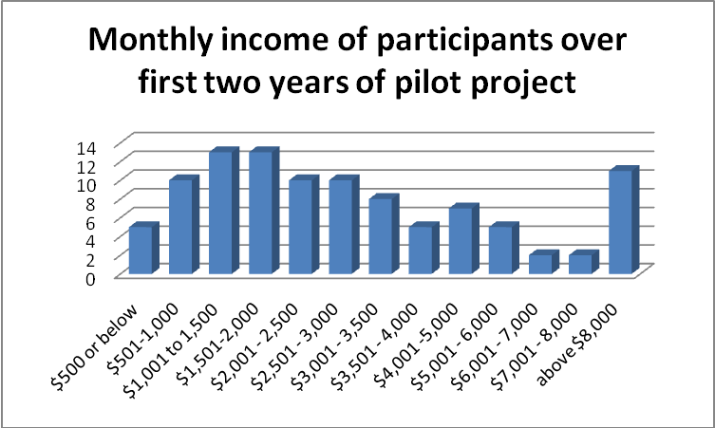

There are no significant differences between the reported monthly income data for the first two reporting periods. The data shows that the pilot project is making mediation available to many North Dakotans of low or limited means. Over 60% of mediation participants during the first two years of the project reported making $3,000 per month or less. However, it is not surprising that there are some participants who could afford to pay for these services. It is entirely appropriate for the court to provide these services on an equal basis to all North Dakotans, regardless of income.

Educational levels of participants are shown in the next table. This data tends towards the middle values, not the extremes. There has been no significant change in this data over the two reporting periods.

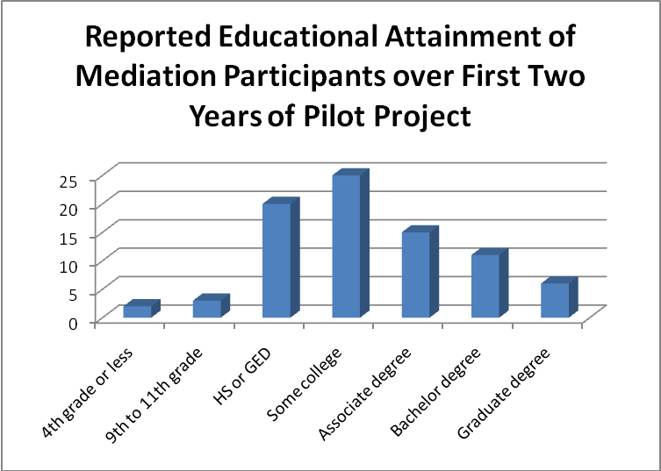

Eighty-nine percent of the participants reported their race as White, five percent as American Indian, two percent as African American, two percent as Hispanic, and two percent as “some other.” The table below shows that minority groups continue to be more heavily represented within mediation participants than within the North Dakota population in general.

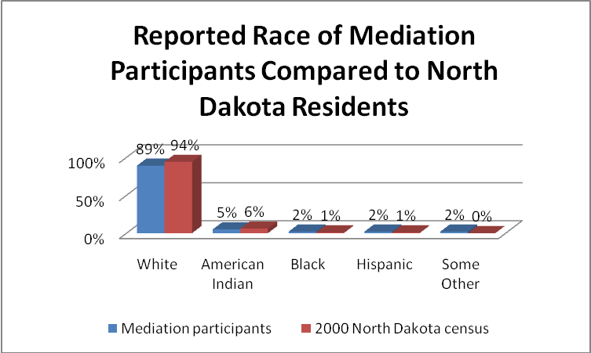

No participants reported a primary language other than English.

A very high percentage of the parties completing surveys reported that they were represented by counsel. Over the first two years of the pilot project, 84% of those responding (284 of 340) reported that they had a lawyer. In many other states more than half of persons responding to this question in family law cases would be unrepresented. It should be noted, however, that the percentage of persons represented by lawyers in family law cases with parenting time disputes appears to be falling in North Dakota. The percentage of reported representation fell by 5% from the first data gathering period to the second.

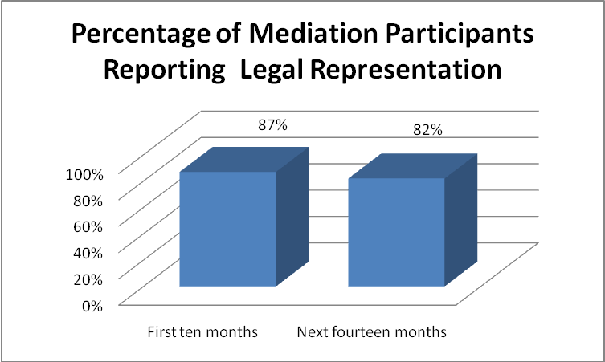

Data Concerning Success in Reaching Agreement through Mediation

Under the terms of Administrative Order 17, parties must mediate their parenting time issues. They may also agree to mediate other issues in the case. The data for the first two years of the program show that the parties are agreeing to mediation of other issues in 59% (131 of 222) of the mediated cases.

The project administrator has stressed with the mediators that reaching agreement is not the highest objective of the pilot project. This is a critically important principle for the North Dakota mandatory mediation program. In programs elsewhere in the country where agreement rates have been stressed as the program’s paramount objective, mediators have been reported to use what many observers would consider to be coercive tactics to obtain agreement.

Despite North Dakota’s de-emphasis on agreement, initial outcomes compare favorably with those in other jurisdictions that have evaluated family court mediation programs.

The table below shows agreement rates for the first and second data gathering periods. It shows a very slight increase in full agreement rates over the life of the program – for both parenting time issues and other issues submitted to mediation. There was a significant drop, however, in the partial agreement rate for parenting time mediations, with a corresponding increase in the “no agreement” rate for those cases. It is somewhat surprising – and a very positive sign for the program – that the full agreement rates for the mandatory aspect of the program are higher than those for the voluntary component. One would suspect that the parties would be less likely to reach agreement when they are forced to mediate than when they volunteer to mediate.

North Dakota Mediation Agreement Rates
 | First Reporting Period  March 1, 2008 to  December 31, 2008 | Second Reporting Period  January 1, 2009 to February 28, 2010 | Total Project Period  March 1, 2008 to February 28, 2010
Full agreement on parenting time | 54% | 56% | 55%
Partial agreement on parenting time | 25% | 14% | 17%
No agreement on parenting time | 21% | 30% | 28%
Full agreement on other issues | 42% | 43% | 43%
Partial agreement on other issues | 22% | 22% | 22%
No agreement on other issues | 36% | 35% | 35%

There are instances in which the parties do not reach agreement at the time of the mediation but, based on the progress made during the mediation in resolving all but one or two issues, reach agreement soon thereafter. The project administrator has kept track of the number of such cases – 30 during the first two years of the project. If those cases were treated as full agreement cases, the full agreement rate would be 68%.

Under the terms of Administrative Order 17, either party may rescind a mediated agreement within five days by notifying the mediator. This provision gives the parties an opportunity to obtain the advice of counsel on a mediated agreement and nullify it based on that advice. During the second data reporting period, we asked mediators to report the number of agreements rescinded. The data was reported for half of the completed cases. It showed rescissions occurred in 15% of cases in which an agreement was reached.

We repeat below the data presented in the first interim report concerning comparative agreement rates, augmented with four more studies, which show that North Dakota’s agreement rates – despite its de-emphasis on agreement as the ultimate objective of the mediation program – are extremely high.

Comparative Agreement Rates Following Family Case Mediation
Jurisdiction | Date of Study | Mandatory/  Voluntary | Full Agreement | Partial Agreement | Combined Full and Partial
Ventura, CA | August 2007 | Mandatory | 55% | 40% | 95%
District of Columbia | 1992 | Voluntary | 80% |  | 80%
North Dakota Pilot Project | 2008 | Mandatory | 54% | 25% | 79%
Charlottesville, VA | 1989 | Mandatory | 77% |  | 77%
North Carolina | 2000 | Not Known | 74% |  | 74%
James City County, VA | 2001 | Voluntary | 72.4% |  | 72.4%
Winnipeg, Canada | 1988 | Voluntary | 65% |  | 65%
Orange County, CA | February 2007 | Mandatory |  |  | 62%
Montreal, Canada | 1988 | Voluntary | 58% |  | 58%
California | 2003 | Mandatory | 44% | 8% | 52%
San Bernardino, CA | September 2008 | Mandatory | 33% | 15% | 48%
Solano County, CA | 2009-2010 | Mandatory | 43% |  | 43%
York County, VA | 2001 | Voluntary | 39.5% |  | 39.5%
Georgia | 2002 | Voluntary | 34% |  | 34%

As explained in footnote 10, some of these comparisons may be questionable. The evaluator is very familiar with California’s mediation program. Other than the fact that mediations are done by court-employed full-time mediators in larger California courts, the California and North Dakota programs are roughly comparable in approach. Two researchers in 1995 summarized outcomes research from dozens of studies done by that date as finding that full agreement varies from 40% to 60% and that partial agreement varies from 10% to 20%. By both of those benchmarks, North Dakota’s pilot mediation project is markedly successful in obtaining agreements.

Do the details of the data on agreement outcomes for the first two years of the pilot project provide any insight into the mediation process in North Dakota?

During the first ten months of the project, agreement rates were relatively consistent among the four case types – divorces, paternity, post-judgment modification, and custody not related to another pending proceeding. Mediation produced agreement at a higher rate in post-judgment cases than in other case types. The lowest success rate – still almost 60% agreement – was in custody matters unrelated to other pending cases.

During the second data reporting period, there was more variation by case type, with full and partial agreement highest in paternity cases, followed by initial divorces, post judgment modifications and custody matters not arising from a pending proceeding. There are still no completed mediations in guardianship cases. Full agreement fell below 50% for post judgment modification cases for the second reporting period, but still remained very close to 50% for the first two years as a whole. Based on this data, we should expect to see lower mediation agreement rates in post-judgment modifications than in other types of cases. However, the success rate in those cases still more than justifies continuing to include them within the mediation project.

Parenting Time Agreement Rates by Case Type
 | First Reporting Period  March 1, 2008 to  December 31, 2008 |  |  | Second Reporting Period  January 1, 2009 to February 28, 2010 |  |  | Total Project Period  March 1, 2008 to February 28, 2010
 | Full agree  ment | Partial agree  ment | Total | Full agree  ment | Partial agree  ment | Total | Full agree  ment | Partial agree  ment | Total
Initial divorce | 46% | 30% | 76% | 61% | 12% | 73% | 58% | 15% | 74%
Post judgment modification | 64% | 18% | 82% | 46% | 18% | 64% | 49% | 20% | 68%
Paternity | 50% | 20% | 70% | 70% | 15% | 85% | 67% | 15% | 82%
Parenting time not arising out of pending case | 57% | 43% | 100% | 30% | 30% | 60% | 41% | 35% | 77%

Full and partial agreement rates for non parenting time issues rose for most of the case types from the first to the second reporting period.

Non Parenting Time Issues Agreement Rates by Case Type
 | First Reporting Period  March 1, 2008 to  December 31, 2008 |  |  | Second Reporting Period  January 1, 2009 to February 28, 2010 |  |  | Total Project Period  March 1, 2008 to February 28, 2010
 | Full agree  ment | Partial agree  ment | Total | Full agree  ment | Partial agree  ment | Total | Full agree  ment | Partial agree  ment | Total
Initial divorce | 42% | 23% | 65% | 61% | 12% | 73% | 51% | 18% | 70%
Post judgment modification | 38% | 25% | 63% | 46% | 18% | 64% | 24% | 29% | 54%
Paternity | 50% | 13% | 63% | 70% | 15% | 85% | 47% | 27% | 73%
Parenting time not arising out of pending case | 33% | 67% | 100% | 30% | 30% | 60% | 43% | 29% | 71%

The first interim evaluation noted that mediation outcomes were more successful in Grand Forks County than in Burleigh County on every dimension. It noted the long tradition of mediation in Grand Forks County, created largely as a result of the work of the Conflict Resolution Center at the University of North Dakota which had been in existence for 22 years at the time of that report. It predicted that the agreement levels in Burleigh County would rise towards those in Grand Forks County over time as the Bismarck bar became more familiar with, and confident of, mediation.

During the second data reporting period, the agreement rates in parenting time mediations dropped somewhat in Grand Forks County and increased in Burleigh County for full agreements while plummeting from 30% to 6% for partial agreements. The gap between the two counties has narrowed for full agreement from roughly 20% to 10%, while it has increased from 3% to 17% for partial agreements. The total agreement rate gap has actually increased from 16% to 20%. The experience of the other counties (some of which are in the South Central and Northeast Central Districts) is very similar to that of Burleigh County.

Parenting Time Agreement Rates by County
 | First Reporting Period  March 1, 2008 to  December 31, 2008 |  |  | Second Reporting Period  January 1, 2009 to February 28, 2010 |  |  | Total Project Period  March 1, 2008 to February 28, 2010
 | Full agree  ment | Partial agree  ment | Total | Full agree  ment | Partial agree  ment | Total | Full agree  ment | Partial agree  ment | Total
Burleigh County | 45% | 30% | 75% | 52% | 6% | 58% | 50% | 13% | 63%
Grand Forks County | 64% | 27% | 91% | 59% | 23% | 81% | 60% | 24% | 83%
All other counties | 50% | 0% | 50% | 53% | 8% | 61% | 53% | 7% | 60%

As shown in the table below, there is very little difference among the three counties/county groupings on agreement rates for non parenting time issues over the first two years of the pilot project, except for the extent of partial agreements, which is much higher in Grand Forks County.

Non Parenting Time Issues Agreement Rates by County
 | First Reporting Period  March 1, 2008 to  December 31, 2008 |  |  | Second Reporting Period  January 1, 2009 to February 28, 2010 |  |  | Total Project Period  March 1, 2008 to February 28, 2010
 | Full agree  ment | Partial agree  ment | Total | Full agree  ment | Partial agree  ment | Total | Full agree  ment | Partial agree  ment | Total
Burleigh County | 44% | 33% | 78% | 41% | 3% | 45% | 42% | 7% | 49%
Grand Forks County | 38% | 25% | 63% | 42% | 39% | 81% | 42% | 38% | 80%
All other counties | 25% | 0% | 25% | 48% | 28% | 76% | 45% | 14% | 59%

Ironically, the data on rescission rates from the second reporting period shows Grand Forks County with the highest rescission rate (19%), followed by the other counties (15%), with Burleigh County having the lowest rescission rate (11%).

Did some mediators have higher success rates than others? Yes, but – given the Supreme Court’s de-emphasis of the importance of achieving agreement through mediation – none of the mediators lacks sufficient success to question his or her capabilities to continue to participate in the pilot project. The high number of rescissions reported by Mediator 10 is a cause for concern. The list of mediators below is not in alphabetical order, in order to preserve the anonymity of the mediators. Greacen Associates is providing the project administrator with a report on each mediator, which can be shared with that mediator.

Mediation Agreement Rate by Mediator
 | First Reporting Period  March 1, 2008 to  December 31, 2008 |  |  |  | Second Reporting Period  January 1, 2009 to February 28, 2010 |  |  |  |  | Total Project Period  March 1, 2008 to February 28, 2010
 | Full | Partial | Total % | Non parent  Ing issues % | Full | Partial | Total % | Non parent  Ing issues % | Re  scis  sions | Full | Partial | Total % | Non parent  Ing issues % | Re  scis  sions
Mediator 1 | 5 | 0 | 71% | 40% | 14 | 0 | 100% | 100% | 0 | 19 | 1 | 91% | 81% | 0
Mediator 2 | 4 | 3 | 100% | 100% | 11 | 5 | 89% | 100% | 1 | 15 | 8 | 92% | 100% | 1
Mediator 3 | 2 | 0 | 50% | 50% | 10 | 0 | 50% | 60% | 1 | 12 | 0 | 50% | 56% | 1
Mediator 4 | 3 | 2 | 63% | 63% | 2 | 0 | 100% | 100% | 0 | 5 | 2 | 70% | 67% | 0
Mediator 5 | 3 | 1 | 100% | 100% | 6 | 1 | 54% | 33% | 1 | 9 | 2 | 65% | 46% | 1
Mediator 6 | 1 | 1 | 50% | 0% | 6 | 1 | 64% | 67% | 2 | 7 | 2 | 56% | 50% | 2
Mediator 7 | 1 | 2 | 100% | 0% | 6 | 1 | 47% | 40% | 1 | 7 | 3 | 56% | 36% | 1
Mediator 8 | 1 | 0 | 100% | - | 7 | 1 | 53% | 40% | 0 | 8 | 1 | 60% | 44% | 0
Mediator 9 | 1 | 1 | 100% | 67% | 8 | 1 | 69% | 80% | 1 | 9 | 2 | 73% | 75% | 1
Mediator 10 | 3 | 1 | 80% | 75% | 3 | 9 | 75% | 60% | 5 | 6 | 9 | 75% | 62% | 5
Mediator 11 | 0 | 1 | 100% | 100% | 2 | - | 100% | - | 0 | 2 | 1 | 100% | 100% | 0
Mediator 12 | 2 | 0 | 100% | 100% | 10 | 4 | 100% | 67% | 0 | 12 | 4 | 100% | 75% | 0
Mediator 14 |  |  |  |  | 1 | - | 100% | 100% | 0 | 1 | - | 100% | 100% | 0
Mediator 15 |  |  |  |  | 1 | - | 100% | - | 0 | 1 | - | 100% | - | 0
Mediator 16 |  |  |  |  | 2 | 4 | 83% | 80% | 1 | 2 | 4 | 100% | 80% | 1
Mediator 17 |  |  |  |  | 3 | 1 | 80% | 75% | 0 | 3 | 1 | 80% | 75% | 0
Mediator 18 |  |  |  |  | 1 | - | 50% | 50% | 0 | 1 | - | 50% | 50% | 0
Mediator 19 |  |  |  |  | 1 | - | 100% | - | 0 | 1 | - | 100% | - | 0
Mediator 20 |  |  |  |  | 1 | - | 100% | 100% | 1 | 1 | - | 100% | 100% | 1

As with the data for the first interim report, the data for the second reporting period continues to show that agreement success rates are lowest at the extremes of participant education levels – agreement on parenting time was at 50% for persons with a 9th to 11th grade education (although there were only two such cases) and at 29% for parenting time and 17% for other issues for persons with graduate degrees.

The data for the full two year period shows some variation in the likelihood of reaching agreement by age – showing that participants above the age of 45 are less likely to reach agreement and more likely to rescind an agreement reached than are younger participants.

Percentage Agreement by Age of Mediation Participants
Age Grouping | Agreement on Parenting Time Issues |  |  | Agreement on Other Issues |  |  | Rescission
Age Grouping | Full agree  ment | Partial agree  ment | Total | Full agree  ment | Partial agree  ment | Total | Rescission
18-24 | 58% | 16% | 74% | 13% | 50% | 63% | 13%
25-34 | 49% | 29% | 78% | 45% | 28% | 73% | 19%
35-44 | 64% | 9% | 73% | 47% | 13% | 60% | 10%
45-54 | 41% | 6% | 47% | 39% | 8% | 46% | 43%

There is some evidence, as shown in the chart on the next page, that agreement rates tend to be highest – and that rescission rates are lowest – in the middle income ranges. Level of income does not seem to affect the willingness of parties to agree to mediate non-parenting time issues. With one exception (for monthly incomes from $4001 to $5000) agreement to mediate other issues was at 65% or higher across income levels.
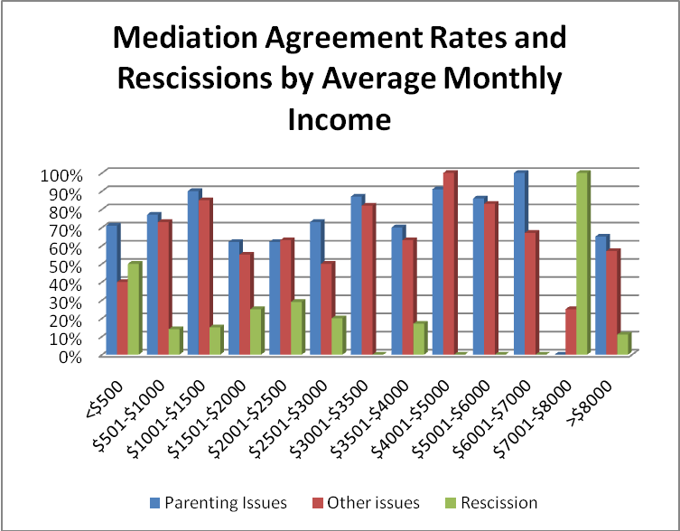

Participant Satisfaction Ratings

We present the participant satisfaction data from a database of 251 completed participant questionnaires for the second data reporting period and from a database of 338 completed questionnaires for the first two years of the project. We present participant satisfaction data for the first and second reporting periods and for the first two years of the project. We then look for differences in participant satisfaction level by various case and participant characteristics.

Participants reported their satisfaction by responding to various statements with Strongly Agree, Agree, Neutral, Disagree, or Strongly Disagree. For purposes of assessing this data, we have created two alternative scores. The first is the “percentage satisfied” which compares the sum of those responding Strongly Agree and Agree with those responding Disagree and Strongly Disagree. This measure disregards “Neutral” scores. The second assigns the values 5, 4, 3, 2, and 1 to the five ratings. Although this scoring process involves assigning a strict numerical ranking to a series of qualitative statements that may not be related to each other in this strict proportion, it is nonetheless a standard research practice. This scoring practice takes into account the “Neutral” ratings. The maximum score would be 5.0; the minimum would be 1.0; and all “Neutrals” would be 3.0.

The statements were set forth in the survey instrument in both positive and negative formulations to discourage respondents from answering all questions the same way. For reporting purposes, we set forth the statements as they appeared on the survey form but have transformed the average scores as if all statements had been stated in their positive formulation. For example, “The mediator did not care about our case” is reported as 96% satisfied and a 4.32 average even though the actual scores are the converse – 4% and 1.68 respectively.

The scores are set forth in the table below.

Participant Satisfaction Scores
 | First Reporting Period  March 1, 2008 to  December 31, 2008 |  | Second Reporting Period  January 1, 2009 to February 28, 2010 |  | Total Project Period  March 1, 2008 to February 28, 2010
Statement | % Satisfied | Average | % Satisfied | Average | % Satisfied | Average
The mediation was at a time relatively convenient for me | 97% | 4.26 | 94% | 4.19 | 95% | 4.21
The mediator treated me with respect | 98% | 4.61 | 98% | 4.65 | 98% | 4.64
I did not understand the process that we were to follow | 84% | 3.89 | 88% | 4.00 | 87% | 3.98
I was able to say what I needed to say during the mediation | 94% | 4.17 | 92% | 4.04 | 93% | 4.07
I learned something new today about my former spouse | 33% | 2.69 | 27% | 2.51 | 29% | 2.55
I was not well prepared for the mediation today | 94% | 3.95 | 89% | 3.88 | 90% | 3.89
I was able to do a good job representing my point of view | 89% | 3.90 | 91% | 3.86 | 90% | 3.87
The mediator treated both of us equally | 94% | 4.31 | 96% | 4.33 | 95% | 4.33
The mediator did not care about our case | 97% | 4.36 | 95% | 4.30 | 96% | 4.32
We were able to put the needs of the children first | 83% | 3.87 | 73% | 3.59 | 76% | 3.67
I learned today how to negotiate more successfully with my former spouse | 40% | 2.78 | 38% | 2.72 | 39% | 2.73
The mediation process was not fair to me | 93% | 4.08 | 90% | 3.94 | 91% | 3.98
I did not feel safe here today | 95% | 4.36 | 98% | 4.35 | 97% | 4.36
Overall, I am satisfied with the mediation process | 91% | 3.91 | 80% | 3.65 | 83% | 3.72
Mediation is better than going to court | 94% | 4.08 | 86% | 3.95 | 89% | 3.99
The outcome today was worse for me than it would have been in court | 89% | 3.69 | 91% | 3.67 | 90% | 3.68
The mediation included new ideas for resolving our disagreement | 70% | 3.31 | 66% | 3.28 | 68% | 3.28
I had difficulty participating because an interpreter was not present | 99% | 4.45 | 100% | 4.48 | 99% | 4.48
I had difficulty participating because of physical barriers | 97% | 4.44 | 96% | 4.40 | 96% | 4.41

Both scoring processes provide very positive support for the pilot project mediation process over its first two years of operation. Overall, 83% of respondents stated that they were satisfied with the overall mediation process. Of the 19 specific aspects of satisfaction measured, only 7 rated below 90%. Of those, five aspects represented realistic assessments of the project’s most optimistic objectives. In reverse order they are – to enable a former spouse to learn something new about his or her former spouse (29% positive ratings), to enable the participants to learn new negotiating skills (39% positive ratings), to introduce new ideas into parenting time decision making (68% positive ratings), and to put the needs of the children first (76% positive ratings). That these statements have lower ratings than others lends credibility to the data as a whole. We should not be surprised that spouses do not believe that they have learned something new about each other or that they have improved their ability to negotiate with each other. In fact, it is surprising that the satisfaction ratings on the latter aspect were as high as they were – almost 40%.

From the first to the second reporting period, twelve of the scores dropped on the percentage satisfied scale and fifteen dropped on the average score scale. Most of the reductions were relatively insignificant. The most significant drop was in overall satisfaction with the mediation process – from 91% satisfied to 80% and from 3.91 to 3.65 on the average score (a 7% drop). It is difficult to understand why overall satisfaction would be at 80% while the other ratings that one would expect to aggregate to determine overall satisfaction were so much higher. See the tables below.

Other satisfaction factors |  | Overall satisfaction
  Comparison to court |  | Overall satisfaction
  Better than going to court | 86% | 80%
  Outcome better than court would have been | 91% | 80%
Convenience | 94% | 80%
Treated with respect | 98% | 80%
Understanding of process | 88% | 80%
Ability to say what needed to be said | 92% | 80%
Well prepared | 89% | 80%
Did a good job representing myself | 91% | 80%
Treated equally | 96% | 80%
Mediator cared | 95% | 80%
Fairness | 90% | 80%
Safety | 98% | 80%

The best explanation would appear to be that the overall satisfaction score reflects not only the participant’s satisfaction with the mediation process but also – to a lesser but still significant extent – her or his satisfaction with the outcome of the process. Although it is of concern that overall satisfaction fell from 91% to 80% from the first to the second data collection period, the overall satisfaction rating of 83% over the first two years is quite high and reflects well on the project.

The other scores that dropped by 5% or more on the percentage satisfied scale were “learned something new about my spouse today (from 33% to 27%), “was well prepared” (from 94% to 89%), “we were able to put the needs of the children first” (from 83% to 73%), and “mediation is better than going to court” (from 94% to 86%).

Six scores increased from the first to the second reporting period on the percentage satisfied scale. The most significant increases were in the two areas to which we drew attention in our first interim report. “I understood the process we were to follow” rose from 84% to 88%. “I felt safe here today” rose from 95% to 98%.

Do the details of this initial data on satisfaction ratings provide any insight into the mediation process?

The overall satisfaction scores were 84% for the Northeast Central District, 83% for the South Central District, and 79% for the other three districts combined. There were no striking differences among the individual scores for the different districts. Convenience was lowest in the three new districts, which is understandable because they are more rural. Perception that the participants would do better in court was higher in the new districts. On the other hand, ratings for the equal-handedness, caring, and fairness of the mediators were highest in the three new districts.

Over the first two years of the pilot project, overall satisfaction scores were higher for the 47 participants who were not represented by counsel (91% positive) than for the 234 who were (80% positive). The breakdown of satisfaction scores for represented and unrepresented litigants on all of the satisfaction questions is shown below. Unrepresented litigants gave the project higher scores except in three areas where having a lawyer appeared to help – in understanding the process (90% represented versus 80% unrepresented), feeling well-prepared for the mediation 93% for represented versus 90% for unrepresented), and feeling that they did a good job representing themselves (90% for represented versus 89% for unrepresented).

Satisfaction Ratings for Represented and Unrepresented Participants
Statement | Percentage Satisfied
 | Represented | Unrepresented
The mediation was at a time relatively convenient for me | 86% | 95%
The mediator treated me with respect | 98% | 100%
I did not understand the process that we were to follow | 90% | 80%
I was able to say what I needed to say during the mediation | 95% | 97%
I learned something new today about my former spouse | 25% | 27%
I was not well prepared for the mediation today | 93% | 90%
I was able to do a good job representing my point of view | 90% | 89%
The mediator treated both of us equally | 94% | 98%
The mediator did not care about our case | 95% | 96%
We were able to put the needs of the children first | 74% | 76%
I learned today how to negotiate more successfully with my former spouse | 33% | 43%
The mediation process was not fair to me | 90% | 93%
I did not feel safe here today | 96% | 98%
Overall, I am satisfied with the mediation process | 80% | 91%
Mediation is better than going to court | 87% | 92%
The outcome today was worse for me than it would have been in court | 88% | 96%
The mediation included new ideas for resolving our disagreement | 63% | 78%
I had difficulty participating because an interpreter was not present | 98% | 100%
I had difficulty participating because of physical barriers | 96% | 98%

The differences in the comparative satisfaction scores are sufficiently small that it appears that attorneys are not systematically biasing their clients against the mediation process.

Participant satisfaction scores for individual mediators were consistently high. There are relatively few surveys for some of the mediators. Shaded columns indicate that a mediator’s scores are based on fewer than 10 completed participant surveys. The only scores that seem at all troublesome are Mediator 7’s rating of 78 for “I was able to say what I needed to say” and the ratings for Mediators 4 and 6 of 75 “I did not understand the process that we were to follow.”

We will provide individual reports for each mediator, along with the average project-wide satisfaction percentages, for the project administrator to provide to the mediators.

Average Participant Satisfaction Scores by Mediator
Statement | Mediator Number
Statement | 1 | 2 | 3 | 4 | 5 | 6 | 7 | 8 | 9 | 10 | 11 | 12 | 14 | 15 | 16 | 17 | 18 | 19 | 20
The mediation was at a time relatively convenient for me | 97 | 100 | 86 | 94 | 92 | 97 | 94 | 100 | 100 | 93 | 100 | 90 | 100 | 100 | 100 | 83 | 100 | 100 | 100
The mediator treated me with respect | 100 | 97 | 100 | 89 | 97 | 97 | 100 | 100 | 94 | 100 | 100 | 100 | 100 | 100 | 100 | 100 | 100 | 100 | 100
I did not understand the process that we were to follow | 80 | 91 | 86 | 75 | 97 | 75 | 81 | 90 | 88 | 88 | 100 | 95 | 100 | 100 | 100 | 100 | 100 | 0 | 100
I was able to say what I needed to say during the mediation | 97 | 97 | 95 | 94 | 93 | 90 | 78 | 96 | 94 | 89 | 100 | 95 | 100 | 100 | 100 | 100 | 100 | 100 | 100
I learned something new today about my former spouse | 73 | 44 | 20 | 27 | 19 | 41 | 21 | 21 | 27 | 28 | 100 | 29 | 0 | 0 | 0 | 67 | 50 | - | 50
I was not well prepared for the mediation today | 85 | 100 | 90 | 87 | 92 | 86 | 86 | 89 | 94 | 100 | 100 | 57 | 100 | 100 | 100 | 100 | 0 | 100 | 100
I was able to do a good job representing my point of view | 100 | 93 | 94 | 79 | 95 | 88 | 77 | 100 | 100 | 81 | 100 | 94 | 100 | 100 | 83 | 80 | 50 | 100 | 100
The mediator treated both of us equally | 97 | 91 | 100 | 75 | 96 | 100 | 97 | 100 | 94 | 97 | 100 | 91 | 100 | 100 | 88 | 100 | 100 | 100 | 100
The mediator did not care about our case | 94 | 97 | 100 | 100 | 92 | 93 | 100 | 96 | 94 | 93 | 100 | 95 | 100 | 100 | 88 | 100 | 100 | 100 | 100
We were able to put the needs of the children first | 79 | 88 | 85 | 81 | 77 | 59 | 66 | 77 | 89 | 75 | 100 | 82 | 100 | 100 | 60 | 83 | 0 | - | 100
I learned today how to negotiate more successfully with my former spouse | 38 | 44 | 39 | 27 | 22 | 57 | 21 | 47 | 67 | 39 | 100 | 29 | 100 | 100 | 0 | 71 | 0 | - | 50
The mediation process was not fair to me | 97 | 94 | 94 | 86 | 88 | 85 | 96 | 89 | 88 | 93 | 100 | 83 | 100 | 100 | 100 | 100 | 100 | 0 | 100
I did not feel safe here today | 97 | 100 | 100 | 88 | 93 | 93 | 100 | 100 | 95 | 100 | 100 | 100 | 100 | 100 | 100 | 100 | 100 | 100 | 100
Overall, I am satisfied with the mediation process | 87 | 86 | 94 | 79 | 79 | 77 | 76 | 100 | 82 | 78 | 100 | 89 | 100 | 100 | 67 | 71 | 0 | 100 | 50
Mediation is better than going to court | 84 | 82 | 100 | 100 | 86 | 85 | 78 | 100 | 94 | 84 | 100 | 94 | 100 | 100 | 100 | 50 | 100 | - | 50
The outcome today was worse for me than it would have been in court | 93 | 91 | 92 | 100 | 88 | 94 | 92 | 93 | 75 | 90 | - | 60 | 100 | 100 | 100 | 100 | 100 | 100 | 100
The mediation included new ideas for resolving our disagreement | 61 | 60 | 82 | 73 | 58 | 74 | 56 | 88 | 79 | 63 | 100 | 63 | 100 | 100 | 33 | 86 | 0 | - | 100
I had difficulty participating because an interpreter was not present | 100 | 100 | 100 | 100 | 100 | 97 | 100 | 100 | 94 | 100 | 100 | 100 | 100 | 100 | 100 | 100 | 100 | 100 | 100
I had difficulty participating because of physical barriers | 100 | 100 | 95 | 100 | 90 | 93 | 97 | 100 | 95 | 97 | 100 | 95 | 100 | 100 | 88 | 100 | 100 | 100 | 100

The data shows no significant difference in satisfaction among whites and non-whites. Whites had an overall satisfaction score of 82% compared to 79% for non-whites. However, non-whites gave the mediation process 100% scores on treating both parties equally and on the fairness of the process. No non-white expressed concern about the lack of an interpreter or the presence of a physical barrier.

Women and men had the same overall satisfaction with the mediation process (83%). Women’s scores for understanding the process were slightly higher than men’s. Women reported that they were slightly better prepared for the mediation than men. They also had slightly higher fairness scores than men. Men had slightly higher scores for mediation being better than going to court, but women thought that their mediation outcome was better than it would have been in court. Men had higher scores for “being able to say what I needed to say during the mediation,” “doing a good job representing my point of view,” for “learning something new about their former spouse,” and for “putting the needs of the children first.”

The chart below shows the variation in overall satisfaction with the mediation process for different age groups. There were only four surveys for persons in the oldest age group. Other specific satisfaction scores were consistently highest for the youngest age group and lowest for the 45-54 year old group.

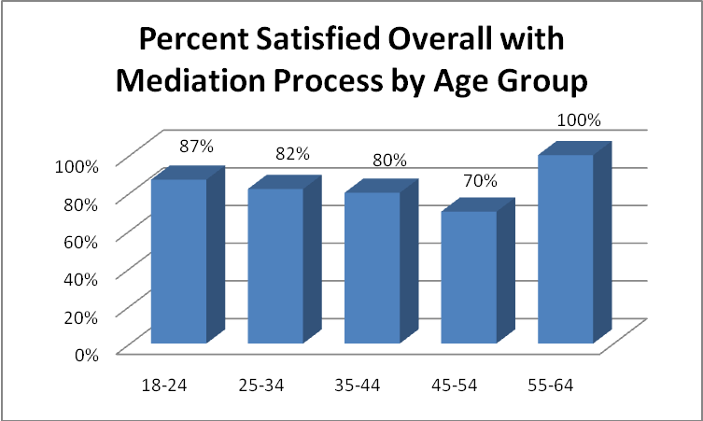

More highly educated persons were somewhat less satisfied overall with the mediation process than persons with lower levels of educational attainment. On other satisfaction scores, the lowest scores were at the highest and lowest end of the educational spectrum (for instance, lack of understanding of the process was highest for the persons with the least education), with persons with a high school education or GED and persons with some college giving consistently high scores on all satisfaction questions. There were no surveys for persons with fifth through eighth grade education.
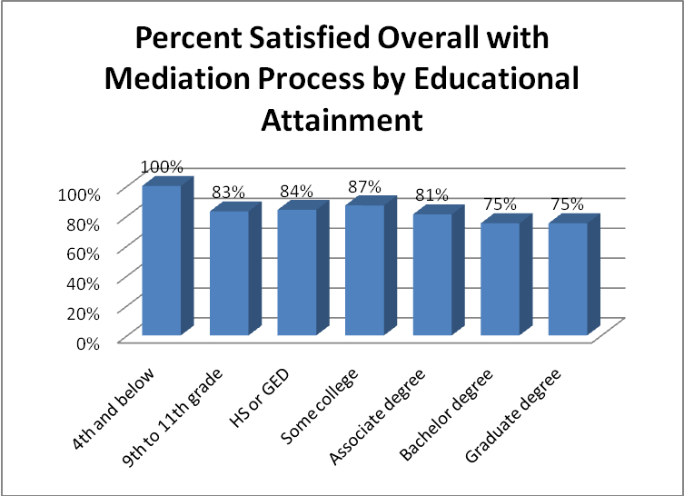

Scores for persons with higher income levels are somewhat higher for overall satisfaction with the mediation process than for persons with lower income levels, although there are notable exceptions. The results are influenced by a relatively low number of surveys in the $6001-$7000 (5) and $7001-$8000 (7) income ranges. There is no consistent pattern for scores on the other satisfaction questions.

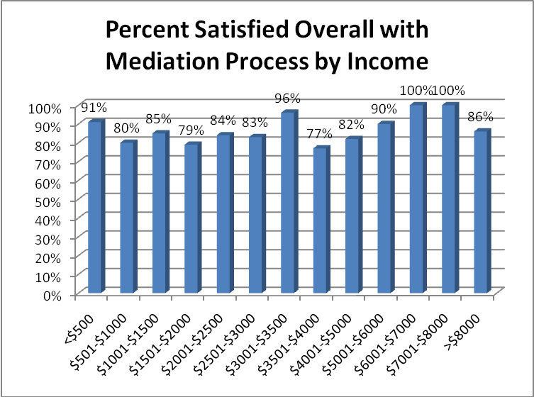

Participant Comments

The survey forms gave mediation participants an opportunity to record the aspects of mediation that were most and least helpful. Here is a full list of those comments with the “most helpful” and “least helpful” comments of each participant reported side by side, along with the county in which the mediation took place.

Our first interim report included a similar set of comments. We have chosen not to repeat them here. Readers wishing to have all of the comments from the first two years of the project’s surveys should refer to the earlier report for comments from the project’s first ten months.

These comments provide sobering material for understanding the context within which parenting time mediation takes place. The parties are often bitter and highly conflicted. The issues separating them are of long-standing. The comments demonstrate the problems faced by North Dakota’s mediators and highlight the significance of the pilot project’s success rate in achieving agreements.

The most consistent positive comment is the value of discussing the issues on which they disagree with a neutral third party.

Participant Comments from Second Data Collection Period
County | Female most helpful | Female least helpful | Male most helpful | Male least helpful
Minot | There was no witness present so that we were able to discuss our issues and keep them private | Didn't get us anywhere | I understand things better | Some of the talking
Minot | Court costs, letting stranger decide the fate of child | No agreement | Different point of views | n/a
Minot | Being able to work out some minor details about custody | Feeling like my concerns weren't a big deal | We at least know what the other person is looking for | The survey
Grand Forks | Gave new options to our situation I wouldn't normally have thought of | n/a | n/a | n/a
Dickinson | How to make decisions on conflicts, the examples she gave us, and to better think about our conflicts | Nothing | The atmosphere was as comfortable as it could be concerning the significance of the topics discussed | None
Minot | [The mediator] was neutral to both of us | Follow up paper work was not done fast enough or sent to our attorneys as quickly as I would like | Putting our wishes and outcome for kids and property down on paper. They kept it simple and straight forward | n/a
Grand Forks | Open and lays it all on the table to see the big issue | Not reaching a conclusion, having to go to court to settle money issues | Mediator was understanding and supportive of both sides | Spouse could not focus on issue
Grand Forks | n/a | n/a | Not going to court | I don't know
Grand Forks | Having the mediator help put out different topics to discuss. We were unable to bring up topics on our own very easily. | n/a | It was nice to have the mediators there to ensure things went smoothly. I believe it helps both sides remain calm and collected. | I was unable to be there due to work and mediation location in Grand Forks
Grand Forks | [The mediator] was very respectful of my needs. I enjoyed working with her. | Mediation was great for the last segment. | Professionalism of mediator | n/a
Grand Forks | Feeling comfortable in small setting rather than court | n/a | The mediators were very kind and understanding | n/a
Grand Forks | Having an objective point of view is very helpful when dealing with emotional issues, such as children. That was one of the most helpful things. | n/a | That M and I were able to hear from a third party how we spoke to each other and how we were communicating about our son's needs | The time allotted and the feeling of not using our time constructively
Grand Forks | The mediator's patience and care with the situation | n/a | Getting him to at least look at other options | Still feel like my back is against the wall -- very helpful though
Grand Forks | [The mediator] talked us through a lot of agreements | It was an overall good experience | n/a | n/a
Grand Forks | Discussing our son's needs | Allowing my ex-husband to rant and rave during our session | n/a | No resolution
Grand Forks | Made him come in for his knowledge | There are other issues that this can't touch due to upcoming court date. | Got some things off mind | n/a
Grand Forks | The ability to speak and have my point of view listened to |  | Staying calm, looking at both sides | n/a
Grand Forks | Best interest was taken. | n/a | Avoided court and hurt feelings about family ties | n/a
Grand Forks | To have a neutral third party involved to explain the choices and options for the future and for the divorce | My ex spouse not being able to understand there is more to life than things | n/a | n/a
Grand Forks | We were able to agree on things | B's having it's my way or no way attitude | We were offered a chance to settle out of court at no expense | n/a
Grand Forks | The pre-mediation, good to sit down and explain the issues and concerns I have | Other parent didn't agree, wants to talk to lawyer first | I got to see what my options are | Nothing resolved
Grand Forks | Talking and working things out -- learning the different way to split time with T--- | n/a | Ability to negotiate | n/a
Grand Forks | Talking it out | n/a | n/a | n/a
Grand Forks | n/a | n/a | L had to be there and listen to what I had to say | Can't really think of anything
Grand Forks | The many different ideas put on the table | n/a | The clear answers from the mediator -- the ability to have answers about how the system works | n/a
Grand Forks |  |  | Agree on custody dispute | Certain terms were already agreed upon and readdressed during mediation
Grand Forks | Provided a means of compromise | Nothing
Grand Forks | We really worked together and he helped which means less time in court | n/a | Having someone to help explain some of my opinions/points to my spouse | n/a
Grand Forks | I felt that they were there to listen and understand things | Nothing | It forced my ex to sit down with me, according to our decree | There was a slight bias toward women -- there were no male mediators -- my ex and I had an agreement but she decided afterwards she didn't like it even though she was getting everything she wanted -- North Dakota has a reputation for supporting the mothers, no matter what their criminal history
Grand Forks |  |  | Nothing was solved but only because of the slim rules of mediation which is a waste of time since nothing really can be solved if the other party doesn't want to cooperate | The fact that issues are only discussed instead of action being able to be taken -- mediation just stirs up more arguing that will never get solved
Grand Forks | Unbiased third party | Absence of lawyers | n/a | n/a
Grand Forks | Was able to get an understanding of what he wants | We weren't able to be in the same room to mediate, so it made it very difficult to mediate | Knowing that I could possibly save a lot of money through mediation rather than spend money on court | n/a
Grand Forks | Having a neutral third party to keep things calm | n/a | n/a | n/a
Grand Forks | n/a | n/a | When both parties participated | When the opposing party cancelled a meeting 12 hours before the meeting -- I still attended, didn't get anything resolved
Grand Forks |  |  | We worked out a visitation schedule without going to court -- we got it done in one day rather than dragging it out in court for a long period of time | n/a
Grand Forks | Was able to hear other point of view without all the screaming and yelling if we tried by ourselves -- we were able to agree on more things | n/a | Finding out my rights as a parent | n/a
Bismarck | I think the mediation was very helpful in keeping us on track and keeping everybody calm -- Initially I didn't realize we would be discussing property settlement issues, but I'm glad we did | n/a | Mediator and his explanation of the process | n/a
Grand Forks | Talking with a neutral person present | n/a | Keeping our emotions at bay by having a lead to our discussions | The requirement of previous legal fees to get to this point
Grand Forks | He couldn’t get upset because someone else was present | n/a | n/a | n/a
Grand Forks | Having a person there to help us come to agreements | Nothing | We were able to sit and talk without getting heated about stuff | n/a
Grand Forks | n/a | n/a | Mediator made other viewpoints possible | Spouse is close minded
Grand Forks | Mediator's skill in helping us come to a compromise | One situation (child's last name) was unable to be resolved | Impartial third person | Not knowing outcome if in court
Grand Forks | Helping to see both sides of concern | n/a | It was easier than anticipated | Nothing
Grand Forks | Nothing | Everything | Being able to talk about the case | Not being able to talk to my baby mama
Grand Forks | n/a | n/a | The mediator was very knowledgeable | Didn't seem like enough time
Grand Forks | She was very neutral | n/a | n/a | n/a
Grand Forks | [The mediator] was willing to listen more and didn't disregard me as much | n/a | Having a mediator to keep things calm and on track | n/a
Devils Lake | We could solve things that we couldn't without the mediator | Nothing | The mediator was instrumental in making both of the parties cooperate | No law in place between sessions -- the other party was not forced to do paper work on time
Grand Forks | n/a | n/a | Was helpful in explaining things better than an attorney would have | n/a
Grand Forks | Everything was explained very well | Nothing | Just going through everything detail by detail | Nothing
Grand Forks | Fight it out between ourselves and not in front of a judge | R's wife | Money | Had to be in a room with my daughter's mother
Minot | [The mediator] tried to help us resolve issues -- she was very professional and made me feel at ease | Spouse wouldn't try to work out our issues | Nothing in my case | Waste of a trip to Minot
Devils Lake | [The mediator] helped me talk to B about my problems | Everything was helpful | Sit down and work it out | Nothing
Devils Lake | Showing us that we do need to communicate for the sake of our son | Not settling this and having to go to court | Being able to see, answer, and talk in person | n/a
Grand Forks | I was able to say what needed to be said | The agreements of custody are roughly regulated | Better than going to court | n/a
Grand Forks | Didn't work for me -- nothing to do with the mediator, only my ex | My ex | Worked on schedule for visitation | Wasn't a lot of communication
Grand Forks | No specific point | The other party yelling at me | The mediator being there and telling us to stop when things were getting out of control -- the mediator offering his point of view | The lack of compromise from H's mother and her unwillingness to communicate with me
Grand Forks | Getting all information out on paper to have it in front and all talked about instead of fought about | My ex spouse not being present at mediation | Someone else seeing reality and presenting the needs of our daughter instead of wants from my ex | Nothing
Grand Forks | I was disappointed that the camera and video link equipment didn't work even 50% of the time in three sessions -- I was grateful that I didn't have to drive from Sioux Falls, but I was disappointed that the equipment didn't work. I felt like I was giving disposition for a trial because I couldn't see them most of the time. | I understand that this is a new program for the state of North Dakota and I'm sure it will get better, I was just disappointed overall in the program. I felt the mediators were too timid and not sure of their place. I wish the program the best moving forward -- I think we were a tough case and not the best one to start with. | I think this process, more than anything, proved my point -- my ex wife has had a divorce and visitation agreement in her favor for nearly 7 years and she still wasn't willing to negotiate. Not only that, but I don't believe that she was challenged at all to do so. | From my perspective, this drug out a process that I knew was going to court --this process was destined to fail -- I felt like the mediators were novices at the process and was disappointed overall -- I saw that the mediator would bill the state at a higher hourly rate than my attorney did, so if I had had my attorney here the need for a mediator would have been zero.
Grand Forks | Mediation was not helpful to me at all | Mediation was too late in the divorce process | n/a | n/a
Bismarck | Being able to say what I needed to say | Nothing | n/a | n/a
Bismarck | [The mediator] clarifying issues that I misunderstood | My ex's lack of communication | Worked out issues re sharing our child | n/a
Bismarck | Need to resolve conflicts | Couldn't agree on anything which makes me frustrated | We could try to talk | Nothing was resolved
Bismarck | Went OK | Went OK | Quick and over fast | The way an entirely new proposal was brought forth by my ex spouse and I had 9 hours to decide life's future -- this is life changing stuff and I was expected to come to a new agreement in fewer than 4 hours -- I also felt deal was done by lawyers before the process even started
Bismarck | Was able to meet on the weekends | n/a | n/a | The mediator does not have a legal background -- she was unable to clarify certain points about determining custody -- if the answer is unknown it would be more beneficial to reply "I don't know" rather than try to guess what the answer is
Bismarck | I learned that I need to do what is right for my children | I was unable to say what I was feeling with my ex and attorney -- kept cutting me off | Trying to come to a solution | Not coming to a solution

Time Required to Complete Mediations

A possible drawback for a mandatory mediation program is that it may delay the resolution of family law cases. Administrative Order 17 was structured to ensure speedy completion of the mediation process. The trial court is to notify the project administrator of a qualifying case within 10 days of filing. There is no time frame for the project administrator’s drafting of the mediation order, its return to the trial judge for signature, its return to the project administrator for distribution, and its dissemination by the project administrator to the parties, attorneys and mediator. The mediator has 90 days from the date of the order to complete the orientations and mediation. Assuming that the time from referral by the trial court to signing of the order takes up to 10 additional days, mediations should be completed within 100 days from referral of a case to the project.

Only 58% of the cases during the first two years of the project (129 of 221) were completed within this time period. Ninety-two cases took longer than 100 days to complete.

The average time required to complete the 222 mediations completed during the first two years of the project was slightly more than 108 days from the date of referral of the case by the trial court – longer but not excessively longer than the time limits set by the Supreme Court in Administrative Order 17. The longest case took 520 days – over 17 months – and the shortest 21 days.

Mediators are instructed to seek an extension of time from the court if the mediation is not completed within the 90 day period set forth in the order. The project administrator noted only two instances in which extensions were requested, one of which was granted. If this data is complete, it would appear that the mediators are cavalierly disregarding the timeliness requirement of the mediation order.

The table on the next page shows the timeliness performance of the mediators in the five pilot districts. Three of the districts had average completion times within the project requirement. The average times for the original two districts and the next three districts were the same.

Timeliness of Mediation Completion by District
District | Cases Completed within 100 Days | Total Cases Completed | Percentage of Cases Completed Timely | Average Time to Complete Mediations
South Central | 51 | 98 | 52% | 122 days
Northeast Central | 68 | 106 | 64% | 99 days
Northeast | 7 | 12 | 58% | 83 days
Northwest | 2 | 2 | 100% | 101 days
Southwest | 1 | 3 | 33% | 73 days
Totals | 129 | 221 | 58% | 108 days

The timeliness of mediation completion varied significantly from mediator to mediator. Times of each mediator are shown in the next table. The performance of Mediators 6 and 12 show that the project’s goal can be attained. The performance of Mediator 5 is so poor that it affects the overall performance of the project. When that mediator’s cases are excluded from the database, the average case is completed within 99 days.

Timeliness of Mediation Completion by Mediator
Mediator | Cases Completed within 100 Days | Total Cases Completed | Percentage of Cases Completed Timely | Average Time to Complete Mediations
Mediator 1 | 9 | 22 | 41% | 123 days
Mediator 2 | 20 | 26 | 77% | 84 days
Mediator 3 | 9 | 23 | 39% | 133 days
Mediator 4 | 7 | 11 | 64% | 112 days
Mediator 5 | 1 | 18 | 6% | 210 days
Mediator 6 | 15 | 16 | 94% | 70 days
Mediator 7 | 12 | 17 | 71% | 76 days
Mediator 8 | 8 | 16 | 50% | 109 days
Mediator 9 | 8 | 17 | 47% | 124 days
Mediator 10 | 13 | 19 | 68% | 98 days
Mediator 11 | 1 | 3 | 33% | 144 days
Mediator 12 | 16 | 16 | 100% | 67 days
Mediator 14 | 1 | 1 | 100% | 70 days
Mediator 15 | 1 | 1 | 100% | 75 days
Mediator 16 | 2 | 5 | 40% | 97 days
Mediator 17 | 3 | 5 | 60% | 102 days
Mediator 18 | 2 | 2 | 100% | 65 days
Mediator 19 | 1 | 1 | 100% | 56 days
Mediator 20 | 1 | 1 | 100% | 21 days
Totals | 129 | 221 | 58% | 108 days

Effect of Mandatory Mediation on Time to Disposition in Family Law Cases

The North Dakota Supreme Court – and a number of members of the North Dakota family law bar – have been concerned that the introduction of mandatory mediation may extend the time that it takes to complete divorce and other family law cases involving parenting time disputes. As noted in the discussion of the data collected for this report, the project administrator and the information technology staff of the Administrative Office of the Court have gone to great lengths to collect data bearing on this issue. This data was not available for the first interim report, but has been provided for this report.

This evaluation presents a preliminary report on the average time to disposition for cases in the pilot project compared with the average time to disposition for cases in the pilot districts before the pilot project began and with cases in one comparison district (the Northwest District) during the same time period as the pilot project. Because the Northwest District was added as an additional pilot, it is also possible to compare its pre- and post-implementation data.

The data is shown in the table on the next page. The table shows the number of completed cases in each data sample, together with the number of cases that remain open. Cases that were dismissed have been deleted from the analysis (2 cases in the South Central pilot case sample and three in the Northeast Central pilot case sample).

To the extent that significant numbers of cases remain open in the pilot district data samples, the average time to disposition for those districts is artificially low. As the open cases are disposed, additional cases with longer time to disposition will be added to the averages. It is for this reason that we consider this only a preliminary report on the time to disposition data.

Average Time to Disposition for Family Cases with a Parenting Time Dispute
District | Number of Completed Cases | Number of Open Cases | Average Time to Disposition
South Central pre-pilot cases | 29 | 1 | 408 days
Northeast Central pre-pilot cases | 10 | 0 | 324 days
South Central pilot cases | 78 | 19 | 286 days
Northeast Central pilot cases | 86 | 16 | 220 days
Northwest comparison cases | 13 | 3 | 352 days
Northwest pilot cases | 3 | 3 | 147 days
Northeast pilot cases | 11 | 10 | 195 days
Southwest pilot cases | 2 | 0 | 107 days

The chart below shows that time to disposition in family cases with parenting time disputes is significantly shorter in the pilot districts since the implementation of the mandatory mediation project – based on the data currently available. As noted previously, this is only a preliminary analysis because there are proportionally more open cases for the post-implementation period in all three districts. We should expect the average time to disposition in those districts to rise as the open cases are disposed.

Nonetheless, the initial indication is positive – that disposition times are definitely not higher following the introduction of mandatory mediation in these three districts.

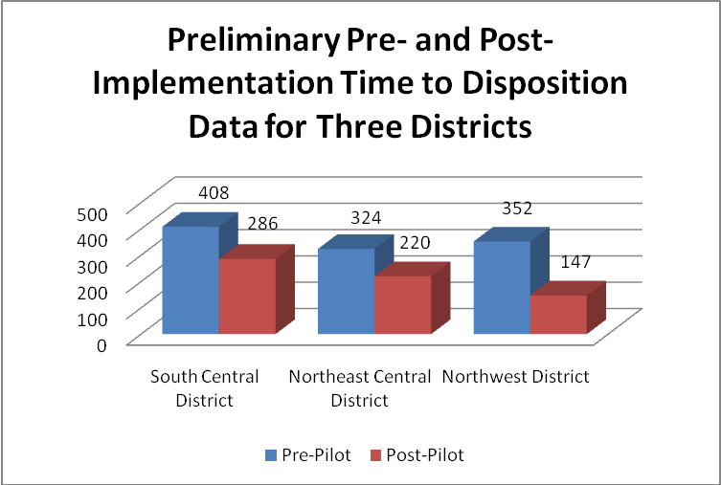

The next chart shows the time to disposition for a reduced number of cases in the South Central and Northeast Central Districts (those filed from March 1, 2008 through July 31, 2008) compared with time to disposition for cases filed during the same time period in the Northwest District, which did not have mandatory parenting time mediation during that time period. There are 20 South Central and 27 Northeast Central cases filed during that period. Two cases – one in each district – were dismissed; those cases are not included in the analysis.

The table shows that while average disposition times in the South Central District were longer than in the Northwest District, when they are averaged with the shorter times in the Northeast Central District, the average disposition time for the pilot project as a whole was shorter than for the Northwest District, which did not have mandatory mediation available. The Northwest District still has three cases open from this time period, while the two original pilot districts combined have no open cases. As the Northwest District disposes of its three open cases, its average time to disposition will increase, showing an even greater improvement for the pilot districts.

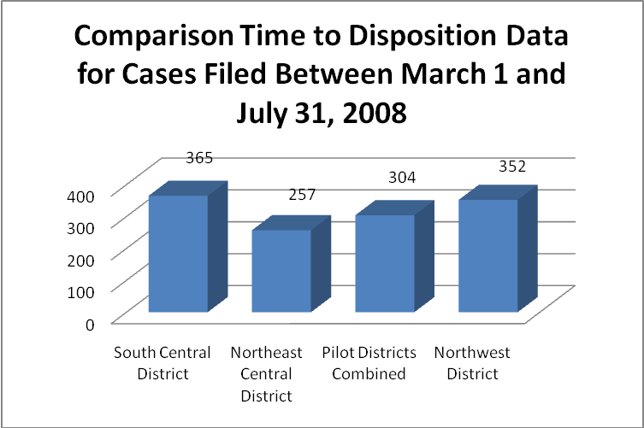

This comparison shows a positive effect for the mandatory mediation project on time to disposition in family law cases involving a parenting time dispute.

Data on the Effects of Mediation Agreements on Subsequent Court Filings to Modify Parenting Time Arrangements

The North Dakota judiciary is also very interested in the frequency with which parties return to court to obtain further court rulings on parenting time and other issues relating to their children. One of the goals of the mediation pilot project is to reduce the number of returns to court by crafting agreements satisfactory to both parties and by providing the parties with enhanced skills to negotiate their own consensual modifications of those agreements.

The project administrator has been recording the number of times cases in the pilot project have been reopened. We are able to compare that data with data for comparison cases from the year before the pilot project began in the South Central, Northeast Central, and Northwest Districts and for cases filed from March 1 to July 31 in the original pilot districts and the Northwest District, which did not have mandatory mediation at that time.

This data is preliminary. As time goes on, more cases will be reopened. Because they have been closed for a longer period of time, it is to be expected that the pre-pilot cases in the original pilot districts will have a higher reopen rate than those during the pilot period. However, by the time the fourth evaluation report has been completed, we expect to be able to report with confidence whether the pilot project has reduced the number of reopening for mediated cases.

The table on the next page shows the data collected to date – the number of cases mediated, the number of reopens for those cases, and the percentage of reopens per completed case.

We use “percentage of reopens per completed case” rather than “percentage of cases that were reopened.” If a case is reopened twice or three times, we count each reopening. If we were counting only the percentage of cases reopened, rather than the number of reopenings, compared to the total number of disposed cases, we would underestimate the burden on the courts from requests to modify parenting time or other child-related issues.

Percentage of Reopenings for Family Cases with a Parenting Time Dispute
District | Number of Completed Cases | Number of Reopened Cases | Percentage of Reopenings
South Central pre-pilot cases | 29 | 23 | 79.3%
Northeast Central pre-pilot cases | 10 | 6 | 60.0%
South Central pilot cases | 78 | 8 | 10.3%
Northeast Central pilot cases | 86 | 15 | 17.4%
Northwest comparison cases | 13 | 2 | 15.4%
Northwest pilot cases | 3 | 0 | 0%
Northeast pilot cases | 11 | 0 | 0%
Southwest pilot cases | 2 | 0 | 0%

The preliminary pre- and post-implementation data for the South Central, Northeast Central, and Northwest Districts is shown in the table below. Please note the dramatically different pattern for the Northwest District during the pre-implementation period. Cases were reopened four times as frequently in the Northeast Central District and five times as frequently in the South Central District, compared to the Northwest District. We would expect to see that pattern continued in the post-implementation period, with the Northwest District having a dramatically lower percentage of reopenings than the other two districts. That is the case, but only because the Northwest District has not had any of its mediated cases reopened yet.

The reduction of reopenings in the original two pilot districts, based on this very preliminary data, is quite promising.

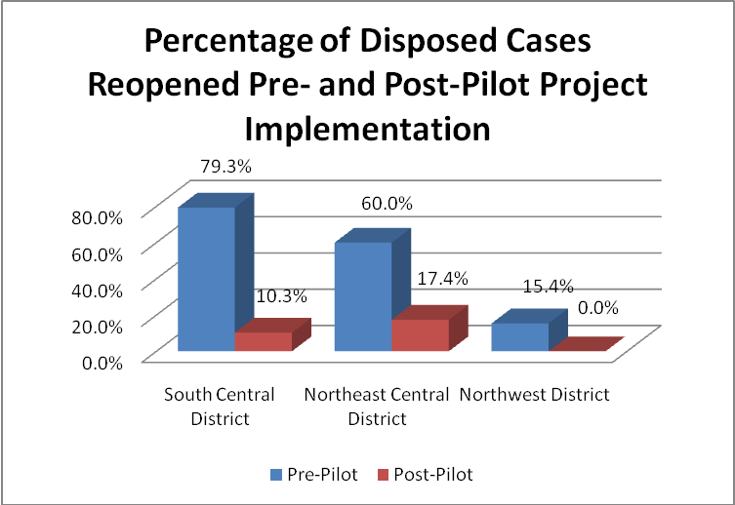
The data is even more promising for the comparison data for cases filed between March 1 and July 31, 2008 in the three districts, shown in the next chart. The original pilot districts had mandatory mediation during this period; the Northwest District did not. Based on the pre-implementation data, we would expect the original pilot districts to have a far higher percentage of reopenings than the Northwest District – by a factor of four or five to one. In fact, the South Central District had a significantly lower percentage, and the two pilot districts combined had a roughly comparable reopening percentage.

This is very positive data, showing that the pilot project reduced the number of reopenings for cases filed during the initial five months of the project.

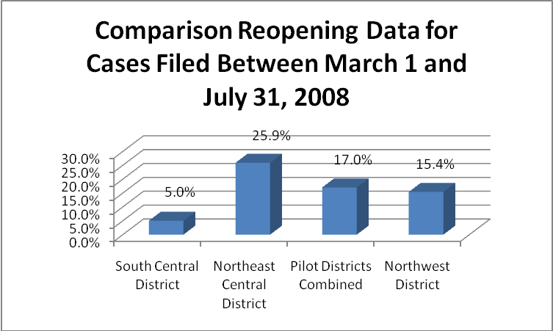

Attitudes of Attorneys, Judges, Court Staff and Mediation Providers

Before the project began and again after the project had been operating for nine months, the project director sent surveys to attorneys in the pilot districts, mediation providers, judges and court staff. The reports of those surveys showed widespread support for the use of mediation to resolve parenting time disputes and other family law matters, with opposition from a minority of the bar.

The evaluator and the project administrator determined that it would not be necessary or productive to conduct additional surveying for this second interim evaluation. Instead, the evaluator and project administrator met in person with groups of judges, court staff, and mediators in Bismarck, Dickinson, Fargo, Grand Forks, and Minot during the first week of August 2010. The attendees at those meetings gave strong support for the project, had minimal problems to report, and reported generally that the project had widespread and growing support within the bar.

Specific comments worth noting were:

From judges
- the mediation project is a success
- it reduces custody fights and frees up judge time
- the mediation process makes it easier for the court to meet North Dakota’s 365 day time to disposition standard for family law cases
- the mediation process saves attorney fees for the litigants
- when full agreement is not reached, the process is nonetheless of value because it narrows the issues between the parties and results in the parties’ having more realistic expectations concerning court hearings and decisions
- practices for scheduling hearings varies from county to county, with one county setting a hearing within 45 to 60 days after filing (with the result that many scheduling hearings occur before the mediation is held and the judge can provide support for the mediation process at the time of the scheduling hearing) while another county waits until the 100th day so that mediation can be completed
- attorney report forms are being filed consistently and timely
- judicial prima facie review of filings for modification of parenting time provisions may not be performed consistently
- an attorney who would file in an adjacent county when the project began (because of the attorney’s opposition to mandatory mediation) is now one of the project’s strongest proponents

From mediators
- it is important to allow the parties to mediate non-parenting time issues because property and custody issues are emotionally connected for the parties
- when the parties need to obtain appraisals of property it may be difficult to complete the mediation within the 90 day time period
- the mediators do not perceive significant power imbalances between the parties during mediation; they are confident that any power imbalances that might arise are nullified by the role of counsel; most mediation participants are represented
- the exception to the above is a case in which only one party is represented; mediators refuse to conduct mediations when only one party’s attorney is present
- the model parenting plan is too complicated; no mediator reported going through all of the plan’s provisions during mediation
- mediators should meet with newly appointed judges (or with judges in districts added to the project) to explain the mediation process
- mediation should be provided to parties seeking help in reaching agreement even though they have not filed a petition in court; steps would have to be taken to insure that parties are not able to select their mediator; the parties or their attorneys could file a written request to the project administrator to initiate the process
- the Supreme Court should consider a two-phase mediation, in which an initial session would be held within 5 days of filing of a petition to address interim parenting time and other arrangements, with a second session to address permanent agreements
- there is too much paper work involved in the process; the mediator log should be eliminated
- mediators should be able to file their reports and invoices electronically
- the mediator’s report should be modified and the process for obtaining the participant surveys should be clarified. In particular, how can the mediator report rescission when the forms have already been completed and sent in to the project administrator?
- mediators should have the opportunity to hold roundtable discussions to share experiences and to become familiar with techniques used by their peers

From court staff
- there continue to be cases that staff overlook; the most frequently overlooked cases are motions to modify parenting time provisions of existing court judgments; the Odyssey report should resolve that problem
- the project administrator should email the court to let the court know of cases that are not accepted for mediation
- what is the process when the parties contest parenting time issues in a case in which those issues were previously uncontested? (answer – notify the project administrator so that the case can be included in the project)
- mediation should take place in paternity cases only after paternity has been established
- the courts are selling many more forms packets for unrepresented litigants
- the Bismarck forms for summary proceedings (cases with assets of no more than $20,000) will be loaded onto the Supreme Court website when all Bismarck judges sign off on them

The clerk of court in Ward County provided data on divorce and paternity filings and trials for the year before that county joined the mandatory mediation project and for the year since. It is shown below. There were no paternity trials in either year.

This data is not sufficient to support any conclusion concerning the effect of the project on divorce and paternity trials and hearings for three reasons: (1) there are relatively few cases in Ward County, (2) there were very few project mediations in Ward County (only three mediations between August 1, 2009 and February 28, 2010 and three more between then and May 30, 2010), and (3) because cases are not necessarily heard during the same year in which they are filed. It may be possible to obtain more information on this topic from Ward County and the other counties as the project proceeds.

However, the Ward County data shows that there were 15.2 trials per hundred divorce filings in the year before the project began in Ward County and 14.9 trials per hundred divorce filings since it began. There were 41.4 hearings per hundred paternity filings during the year before the project began and 31.4 hearings per hundred paternity filings since it began. The difference in the rate of divorce trials is insignificant. The difference in the rate of paternity hearings is noteworthy, but we do not have any way of knowing what proportion of the hearings either before or after the project began actually addressed parenting time issues.

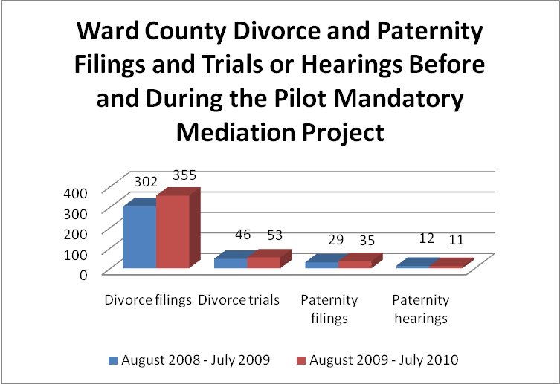

Findings and Recommendations of the Second Interim Evaluation Report

Having reviewed all of the information provided in this report, Greacen Associates makes the following findings and recommendations.

During its initial two years, the Family Law Mediation Pilot Project has been successful in meeting its objectives.

- The project has been implemented successfully from an administrative standpoint, with the establishment of procedures, the selection and training of mediators, the augmentation of the UCIS system to support automated data gathering, the modification of the new Odyssey case management system to support the project, the gathering of survey and other data for the project, and the preparation and adoption of ethical guidelines and a process for enforcement of those guidelines.

- The project has expanded successfully beyond the initial two pilot districts to three additional districts. The project administrator has recruited, selected, and trained additional mediators for the new districts and informed judges and court staff of the project’s procedures. The Supreme Court has decided to make the project statewide, requiring additional recruitment, selection and training of mediators and training for judges and court staff.

- All participants praise the performance of the project administrator.

- The project has assigned mediators and issued mediation orders in 311 cases. Two hundred and twenty-two of those cases were completed by the end of the project’s second year and the results available for analysis.

- The pilot project has reached persons from rural areas of the pilot districts, persons of limited means who could not afford private mediation, and members of minority groups.

- Participants in 59% of cases accepted into the mediation project agree to mediation of non-parenting time issues.

- Project mediators report that they have obtained full agreement on parenting time issues in 55% of the cases completed and partial agreement in an additional 17% of the cases, for a positive impact on 72% of the cases. The full agreement rate increased slightly from the first to second data collection period, but the partial agreement rate fell from 25% to 14%. The agreement rate on non-parenting time issues stayed constant from the first to second data collection period – 43% full agreement and 22% partial agreement.

- If the project were to be given credit for cases that do not reach agreement during the mediation, but settle very soon thereafter, the full agreement rate would be 68%.

- Although North Dakota de-emphasizes agreement as the objective of its mediation project, the project’s agreement rate compares very favorably with that from similar efforts in other states.

- Agreement rates – for non-parenting time as well as for parenting time issues – are highest for paternity cases and lowest for post judgment modifications.

- Mediators in Grand Forks County continue to be more successful in obtaining mediation agreements than mediators elsewhere in the state.

- Mediation agreements are rescinded in 15% of the cases in which agreement is reached. The rescission rate is highest in Grand Forks County.

- Agreement is less likely for persons with graduate degrees than for persons with lesser educational attainment. Older participants are less likely to reach agreement and more likely to rescind an agreement reached. Agreement is more likely for persons with moderate incomes than for persons with very low or very high incomes.

- Participants reported a drop in overall satisfaction with the mediation process from the first to the second data collection period – with average scores falling from 91% to 80%. The two year average score of 83% satisfied with the overall process is nevertheless very satisfactory.

- Twelve specific satisfaction scores dropped from the first to the second data gathering period, while six rose (including the two scores to which the first interim evaluation report had drawn attention – understanding of the process to be followed and feeling of safety). The specific satisfaction scores remain very satisfactory for the two year period.

  - Ratings of mediator respect, fairness, and equal treatment of the parties and the parties’ feelings of safety were over 90%.
  - 89% prefer mediation than going to court; only 10% felt they would have gotten a better outcome in court.
  - 68% reported that mediation introduced new ideas into their discussions.
  - 39% felt they had come away with better negotiation skills.
  - 29% reported that they learned something new about their former spouse.

- Unrepresented litigants are more satisfied with the mandatory mediation process than represented litigants (91% compared to 80%). A very high percentage of participants are represented by counsel, although the percentage fell from 87% to 82% from the first to the second data collection period.

- There are no significant differences in satisfaction with the mediation process based on sex or race. Satisfaction was lowest for older persons, for persons with the highest educational attainment, and for persons with the lowest income levels.

- Mediations are completed within the time frame set by the North Dakota Supreme Court’s Administrative Order 17 in only 58% of the cases. This is a significant deterioration from the first evaluation report, when two-thirds of the cases were being completed within the timeliness requirement. The average time to completion was 108 days, compared with the requirement of completion within 100 days. It does not appear that mediators are asking for extensions of time from the district judges when mediations are not completed within the time set forth in the mediation order.

- Timeliness of mediations varies by district. It also varies significantly by mediator, with one mediator completing 16 of 16 mediations within 100 days of referral of the case to the project administrator and a second completing 15 of 16 within that time. On the other hand another mediator completed only 1 of 16 cases within the time requirement. That mediator took 210 days on average to complete the cases assigned – twice the time specified by the Supreme Court.

- Despite the above finding, preliminary data shows that the average time from filing to court disposition of family cases with parenting time disputes is shorter since implementation of the mandatory mediation project than in the year before it was implemented. The pilot districts on average are disposing of family cases more expeditiously than the control district.

- Preliminary data also shows that the pilot districts are experiencing a lower percentage of reopenings since the mediation project has been implemented. Comparison of the percentage of reopenings of the first two pilot courts with the comparison court shows a particularly positive effect of the project on the likelihood that parties in divorce cases involving children will return to court seeking a modification of their divorce judgment.

- Ward County volunteered data on divorce and paternity filings and hearings and trials in those two types of family cases. The data is not sufficient to show whether the mediation project reduced the percentage of divorce and paternity cases requiring trial or hearing.

- Judges, court staff and mediators in the pilot districts agree that the pilot project is succeeding on all dimensions on which they were asked to provide an opinion. All report that the members of the bar who originally opposed mandatory mediation appear to be more supportive as they experience the mediation process.

We suggest that the Supreme Court and the project administrator consider the following program improvements and modifications:

- The project administrator should pay more attention to the timeliness of completion of mediations and enforce the Supreme Court’s 90 day time limit. While it is undoubtedly the case that some of the mediators are busy family law attorneys who have to schedule their mediations within their regular law office and court practice, the performance of some of the mediators shows that the 90 day completion requirement is realistic. We suggest that the project administrator discuss this issue with the mediators with the poorest timeliness records and suggest that they cease serving as mediators if they cannot comply with the timeliness requirement. We also suggest that the Supreme Court authorize the project administrator to reduce the compensation for mediations that are not completed timely, perhaps on a sliding scale that maintains a continuing incentive for timely performance, such as

  - Failure to complete within 90 days – 25% reduction
  - Failure to complete within 120 days – 50% reduction
  - Failure to complete within 150 days – 75% reduction

- The project administrator should also enforce the requirement that mediators complete the mediator’s report in every case and that they follow the newly articulated procedure for obtaining completed surveys for both participants at the completion of the mediation session – without forcing a participant to fill out a survey if he or she objects. The integrity of the project evaluation depends upon consistent and complete data collection.

- The Supreme Court should consider allowing parties to obtain a court-financed mediation without having to file a court petition or motion. If the mediation settles the dispute between the parties, the court would reap an increased benefit – not having to open, file and track an additional court action. The parties would save attorney’s fees associated with preparing and responding to a court filing. And the total cost to the state should not be expected to increase significantly, because the cases would qualify for state-supported mediation if court papers were filed. In particular, this option might appeal to attorneys in Fargo who otherwise will not make very limited use of the mediation project because their practice is not to file their cases until they are settled.

The process could be initiated by a written request to the project administrator, who would evaluate the request, authorize a mediation when appropriate, and appoint a mediator. She would prepare a mediation authorization that would take the place of a court order, setting the timeliness and other requirements for the participation in the mediation. She should have the discretion to decide that the parties in a particular case should no longer be able draw on the state’s mediation resources because of the number of previous mediation sessions provided to them.

- The Supreme Court and the Administrative Office of the Courts needs to pay continuing attention to creation of a process to ensure that written court orders implementing a mediated agreement are prepared for unrepresented parties in North Dakota. As noted in the report, relatively few North Dakota family law litigants are unrepresented. However, the mediation process cannot be brought to a successful conclusion for unrepresented persons unless there is a mechanism for preparing final court orders. Mediators feel that they would be providing legal advice if they were to perform this service. Final divorce orders frequently must address issues – e.g., child support and division of property – that were not resolved within the mediation process. It is not realistic to expect the parties to prepare appropriate court judgments without the assistance of someone familiar with the process and with court requirements.

We are aware that the Supreme Court and the North Dakota Bar Association have given attention to this issue. However, a solution is not yet in place.

- The project administrator should consider expanding the evaluation to include the collection of data on trial rates in divorce cases before and after the implementation of mandatory mediation of contested parenting time issues. North Dakota judges report that the mediation project has reduced the number of family law trials. It would seem worthwhile to confirm that impression with empirical evidence. The clerk of court in Ward County demonstrated that filings and trial data for her county was readily available from the UCIS system. Greacen Associates would be willing to analyze the data for all the North Dakota courts if it were made available to us for future evaluation reports.

Since the first interim report, the North Dakota legislature has adopted the terminology “parenting time” in lieu of the previously used terms “custody and visitation.”
Two of these cases had completed mediator’s reports, providing some additional information on the case.
The total project period data includes one additional survey for a case analyzed during the first reporting period. The information from that survey appears only in the cumulative data reports.
There is a discrepancy of 3 cases between the project’s records and the data provided to us. The project reports 225 completed cases. We have records for only 222. This report uses the base number of 222 cases for which Greacen Associates, LLC has information.
We are reporting to the project administrator the performance of each mediator in obtaining and sending in the feedback questionnaires.
For this data, we used the cases data set, involving only one survey from each case. This data set had the number of children for 135 of the 173 cases.
There were no participants reporting the educational level of 5th through 8th grades.
Since the first interim evaluation report, the North Dakota legislature has adopted a new vocabulary for family cases. Instead of the terms “custody and visitation,” the law now specifies use of the term “parenting time.”
Mediation outcome was not reported on five of the 222 completed cases.
Comparison of cross-jurisdictional outcomes should be treated with considerable skepticism. This data was gathered from multiple sources. The full context of each program and its evaluation was not available. It is therefore not clear whether the other programs listed were comparable to North Dakota’s program, how full and partial agreements were defined and measured (assessment was left completely to the mediator in North Dakota), or the extent to which participation was mandatory or voluntary (one might expect higher agreement rates in voluntary programs). Note, however, that Benjamin and Irving in their 1995 summary of research on this topic (Benjamin, M. and Irving, H. H., “Research in Family Mediation, Review and Implications,” Mediation Quarterly,1995) conclude that outcomes do not vary significantly on these variables.
Mediator coercion was reported in this jurisdiction.
Full and partial percentages do not always equal total percentages because of rounding.
Full and partial percentages do not always equal total percentages because of rounding.
Full and partial percentages do not always equal total percentages because of rounding.
Missing reported outcome on one case.
Missing reported outcome on one case.
Missing reported outcome on one case.
Missing reported outcome on one case.
There were too few cases for the oldest age group to include in this analysis.
Representation status was not recorded on 56 of the surveys.
Dates were missing for one case.
Data on time to disposition was missing for one case.
The requirement to maintain and submit a mediator log has been eliminated from the reporting requirement as of September 2010.
The mediator’s report and participant survey forms have been modified, taking into account suggestions made by the mediators. The new forms were provided for use beginning the first week of September 2010. Mediators have been provided with a new set of instructions clarifying how rescissions are to be reported.

